Point Intersection

Definition
# Source: AI Source: Provided by: [Data Path: Persons Table -> ID Column: 1, Name_En Column: Motasem Essam] -> From: [ChatGPT] on [7/25/2026]
Point Intersection is a type of geometric intersection that occurs when two or more geometric objects share exactly one common point.
The common point is called the point of intersection.
If two geometric objects $A$ and $B$ intersect at point $P$, we can write:
$$\boxed{A∩B=P}$$
This means that $P$ is the only point common to both objects.
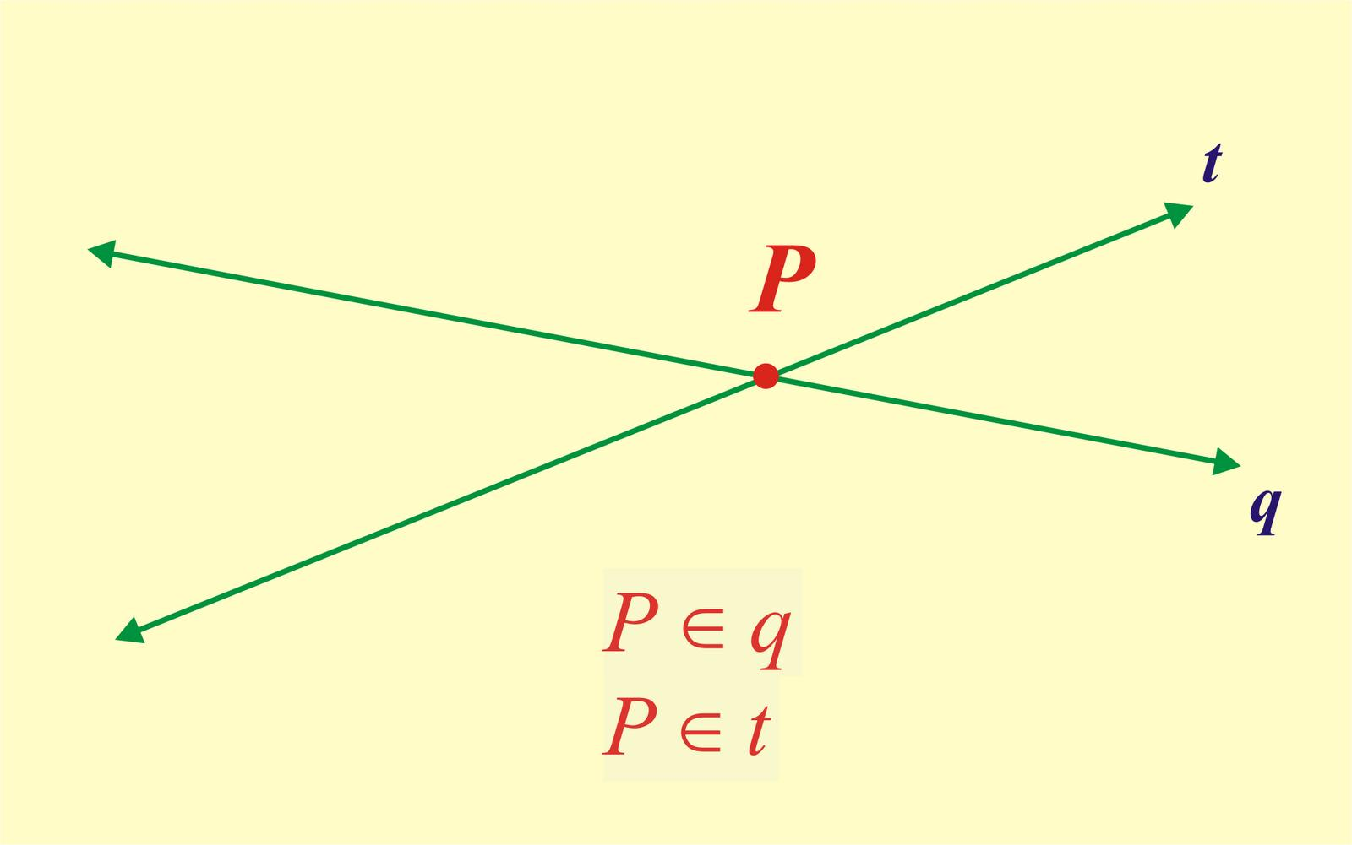
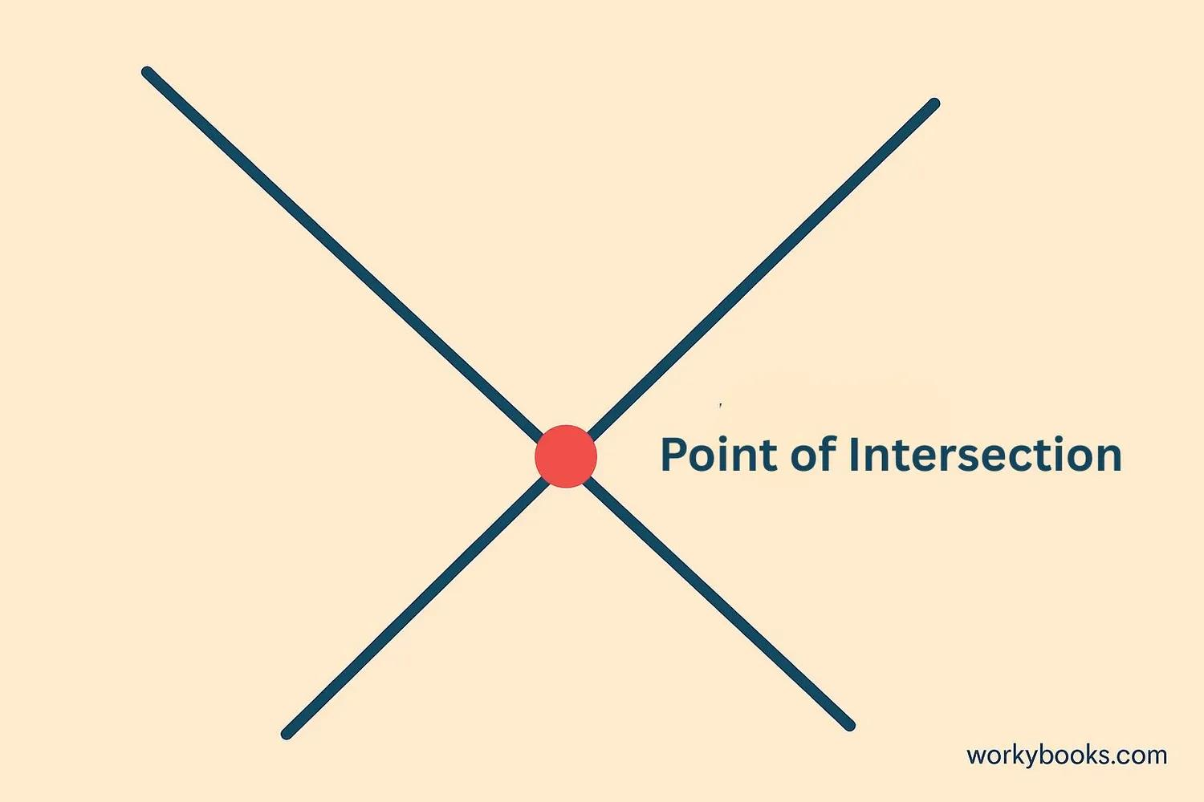
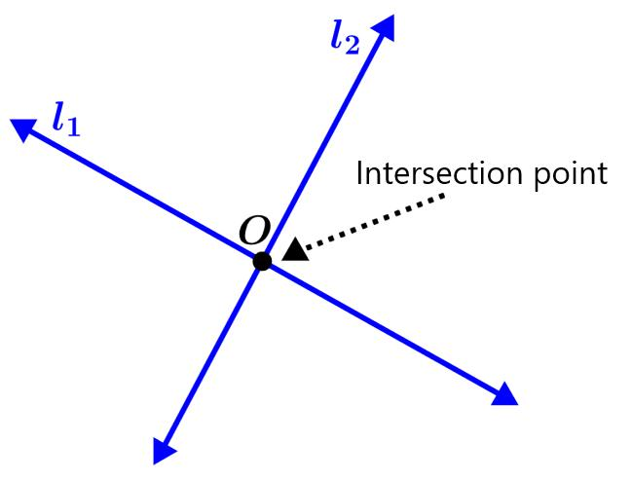
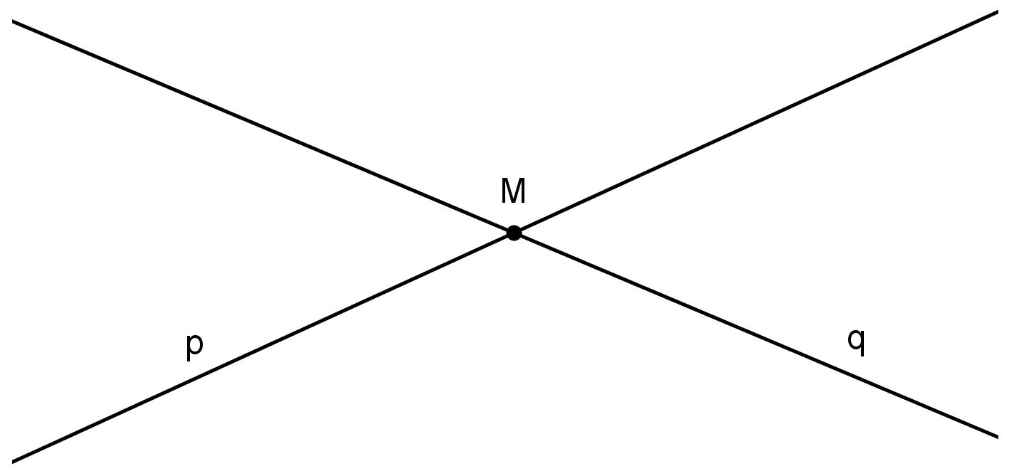
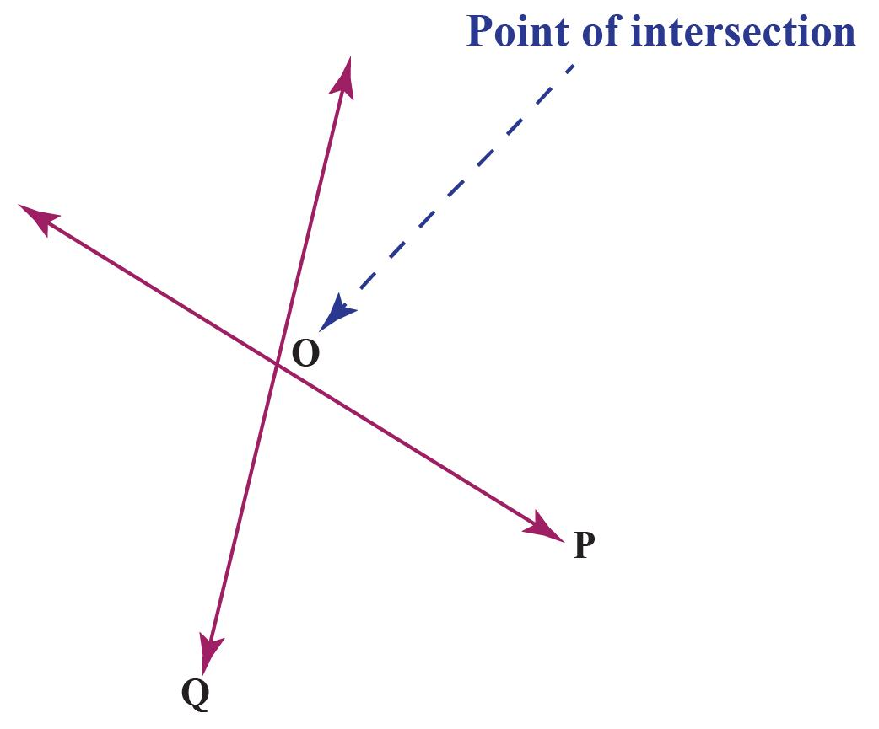

Purpose
# Source: AI Source: Provided by: [Data Path: Persons Table -> ID Column: 1, Name_En Column: Motasem Essam] -> From: [ChatGPT] on [7/25/2026]
Point intersection is used to:
- Identify where geometric objects meet.
- Locate a specific common point.
- Determine the crossing point of lines.
- Solve coordinate geometry problems.
- Analyze geometric figures.
- Find where curves touch or cross.
- Construct angles and geometric shapes.
- Determine locations in maps and engineering drawings.

Fundamental Idea
# Source: AI Source: Provided by: [Data Path: Persons Table -> ID Column: 1, Name_En Column: Motasem Essam] -> From: [ChatGPT] on [7/25/2026]
The main idea of point intersection is:
Two or more geometric objects meet at exactly one common point.
For example:
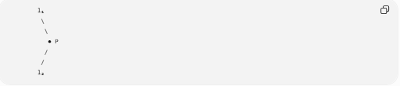
l₁
\
\
● P
/
/
l₂
The two lines meet at $P$.
Therefore:
$$\boxed{l_{1}∩l_{2}=P}$$
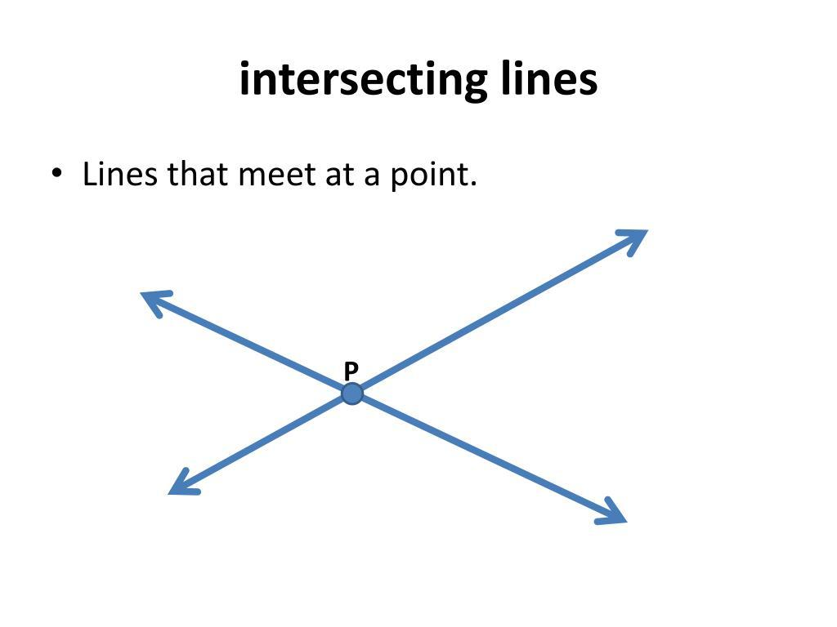
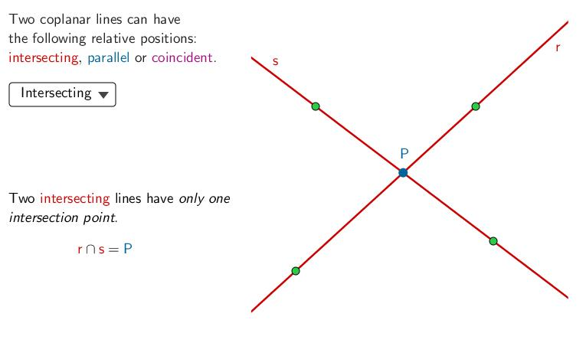
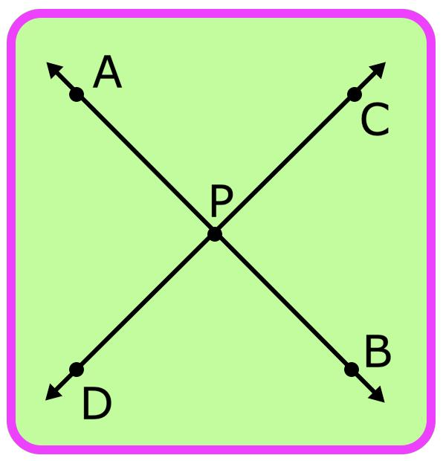

Point of Intersection
# Source: AI Source: Provided by: [Data Path: Persons Table -> ID Column: 1, Name_En Column: Motasem Essam] -> From: [ChatGPT] on [7/25/2026]
The point of intersection is the unique point shared by the intersecting objects.
For example, if lines $AB$ and $CD$ meet at $P$:
$$\boxed{AB∩CD=P}$$
The point $P$ belongs to both lines:
$$\boxed{P∈AB}$$
and:
$$\boxed{P∈CD}$$
Therefore:
$$\boxed{P∈AB∩CD}$$

Intersection of Two Lines
# Source: AI Source: Provided by: [Data Path: Persons Table -> ID Column: 1, Name_En Column: Motasem Essam] -> From: [ChatGPT] on [7/25/2026]
Two non-parallel lines in a plane intersect at exactly one point.
For example:
$$\boxed{l_{1}∩l_{2}=P}$$
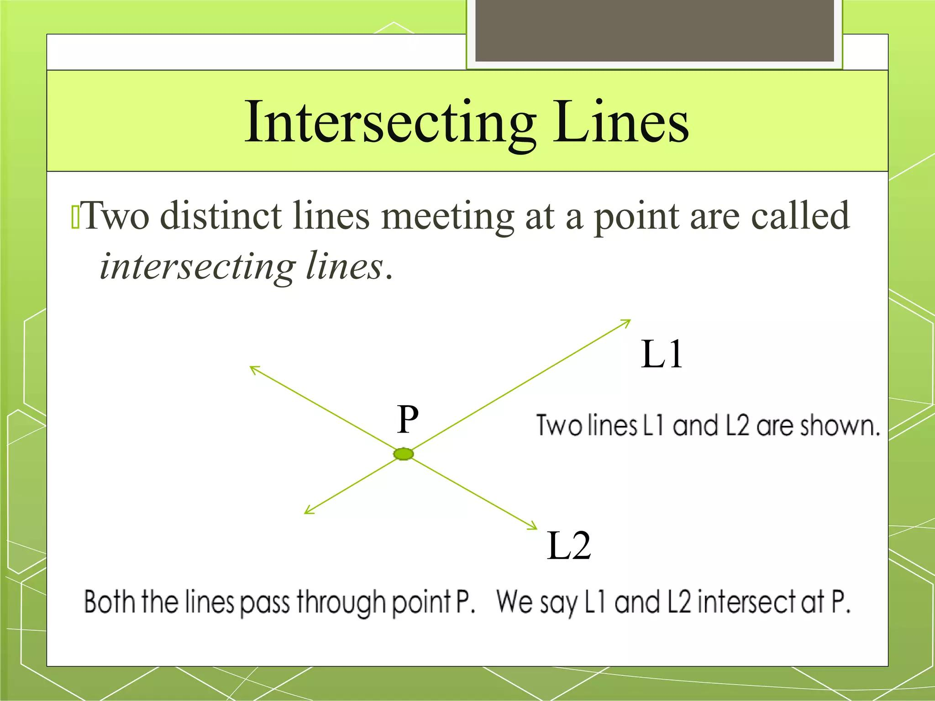
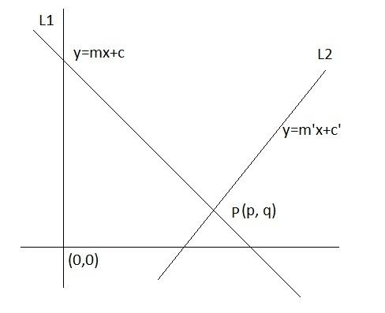
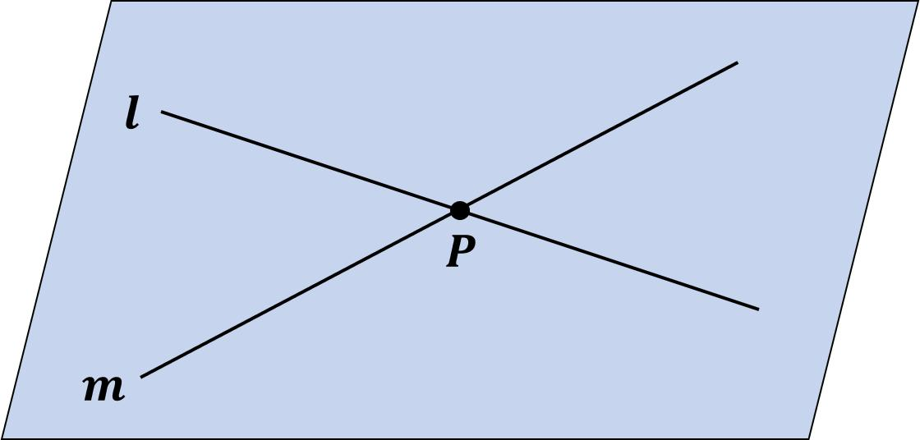
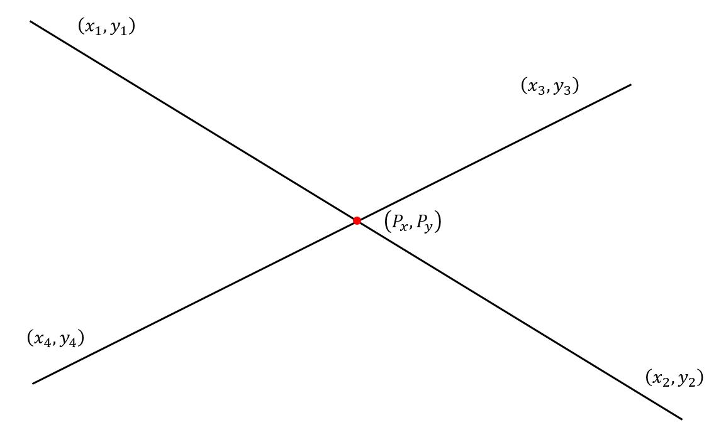
This is one of the most basic examples of point intersection.

Intersection of Two Line Segments
# Source: AI Source: Provided by: [Data Path: Persons Table -> ID Column: 1, Name_En Column: Motasem Essam] -> From: [ChatGPT] on [7/25/2026]
Two line segments can also have exactly one common point.
For example:
$$\boxed{\overline{AB}∩\overline{CD}=P}$$
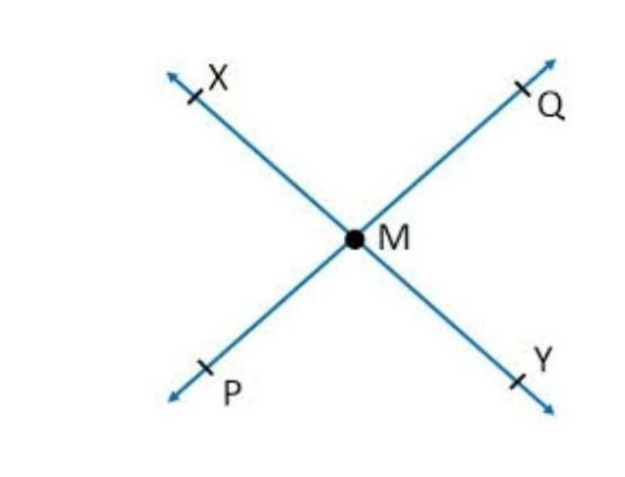
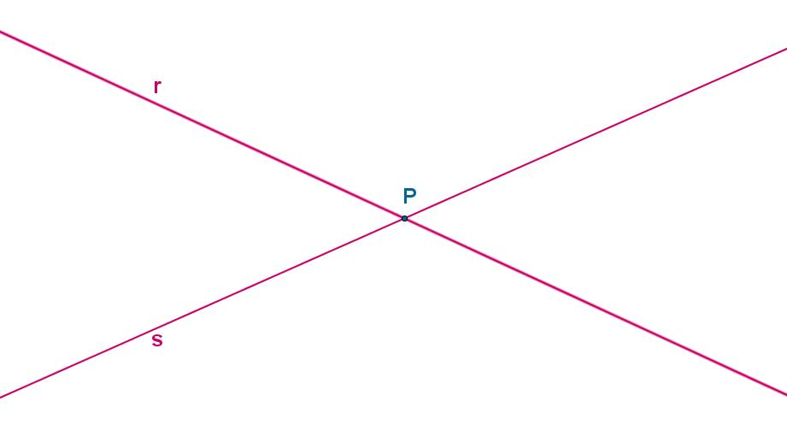
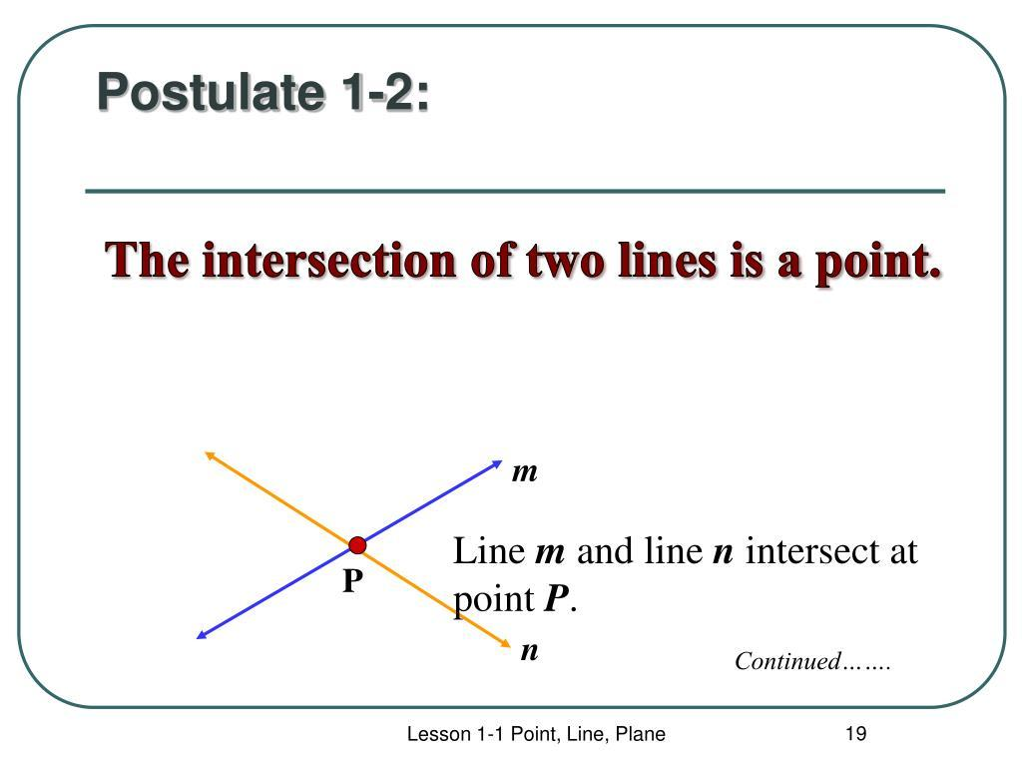
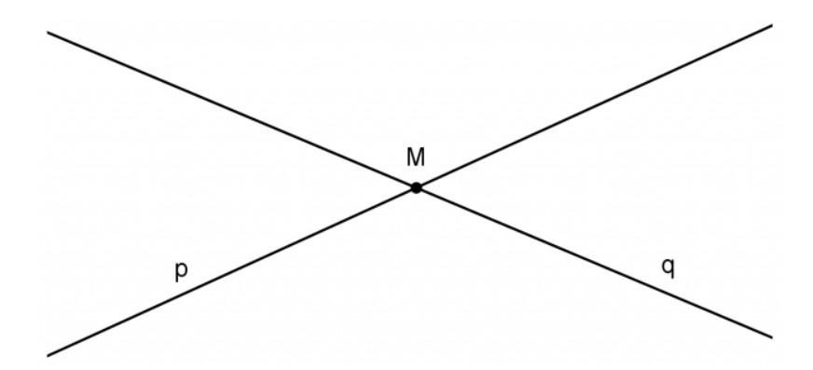
The important difference is that the intersection point must lie within both segments.

Intersection of Two Rays
# Source: AI Source: Provided by: [Data Path: Persons Table -> ID Column: 1, Name_En Column: Motasem Essam] -> From: [ChatGPT] on [7/25/2026]
Two rays may intersect at exactly one point.
For example:
$$\vec{AB}∩\vec{CD}=P$$
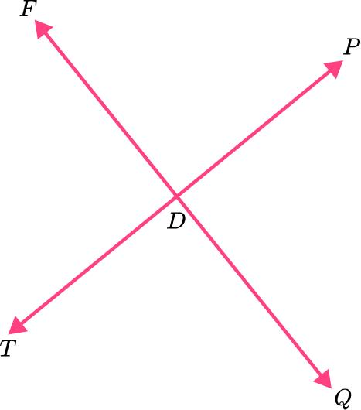

Intersection of a Line and a Circle
# Source: AI Source: Provided by: [Data Path: Persons Table -> ID Column: 1, Name_En Column: Motasem Essam] -> From: [ChatGPT] on [7/25/2026]
A line can intersect a circle at exactly one point when the line is tangent to the circle.
The point is called the point of tangency.
$$\boxed{l∩C=P}$$
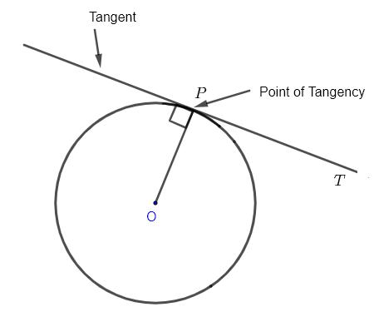
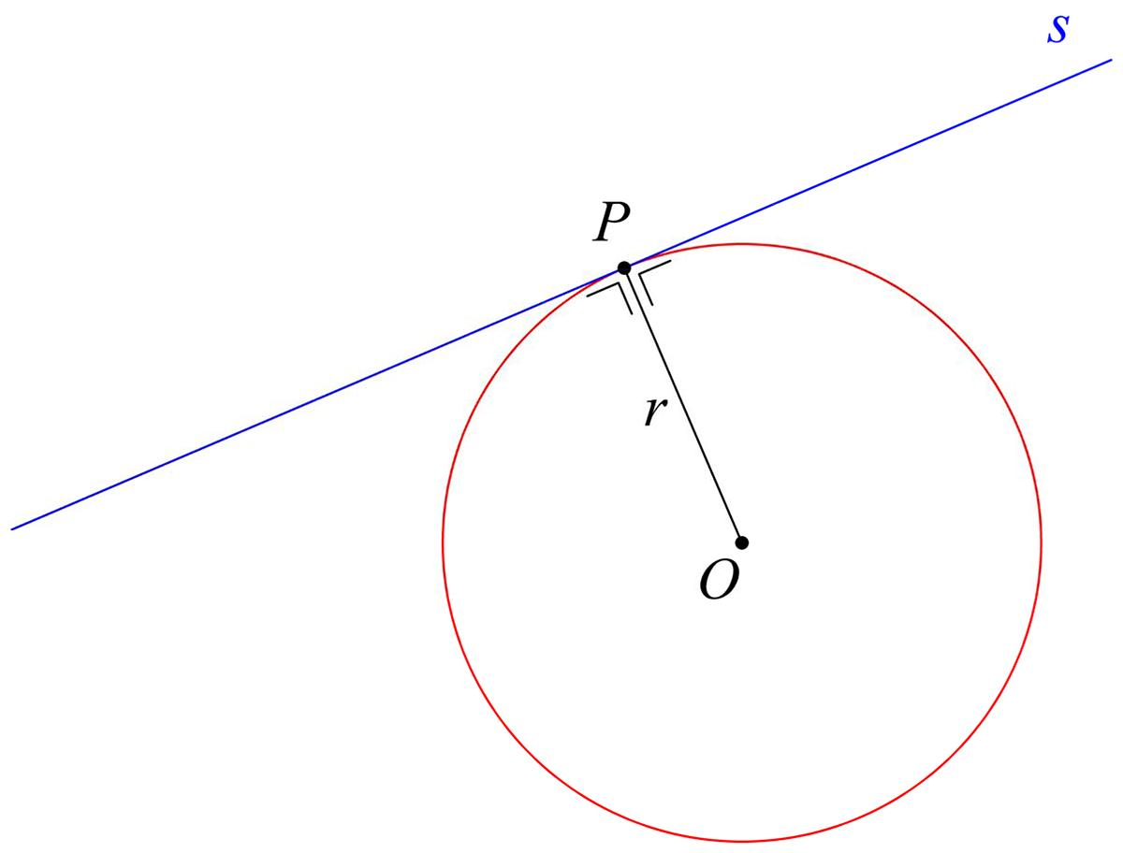
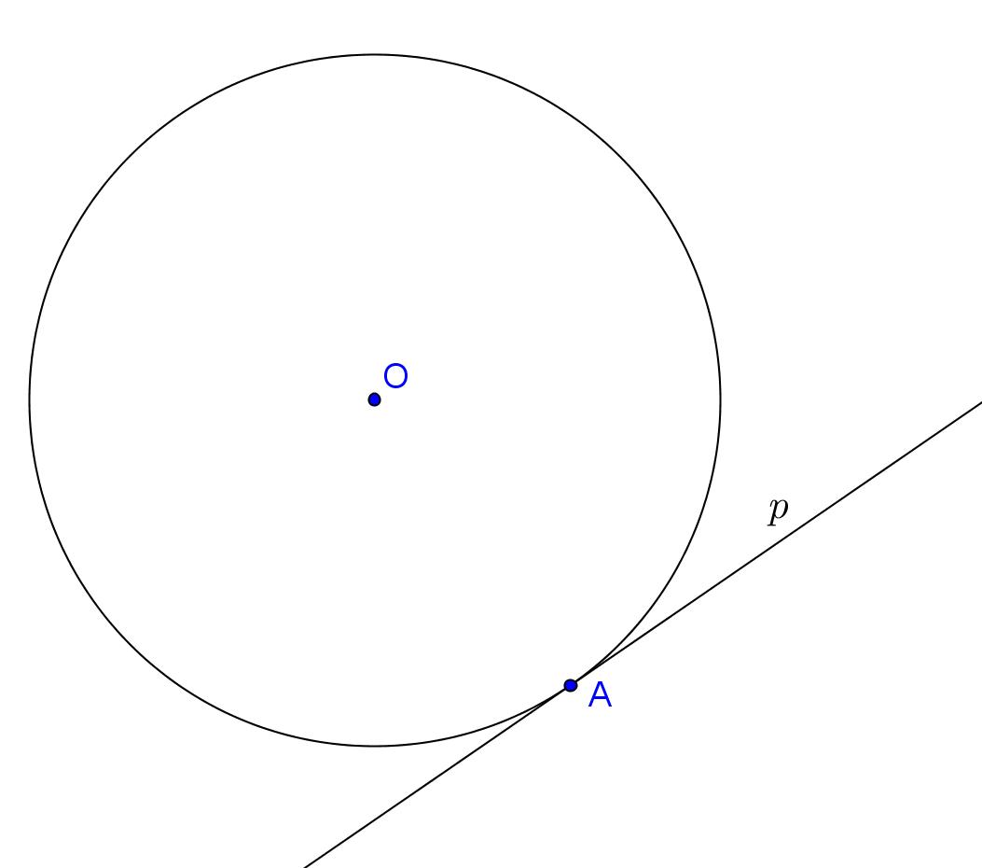
For example:
$$\boxed{\text{Line}∩\text{Circle}=P}$$
This is a point intersection.

Tangency as Point Intersection
# Source: AI Source: Provided by: [Data Path: Persons Table -> ID Column: 1, Name_En Column: Motasem Essam] -> From: [ChatGPT] on [7/25/2026]
A tangent line touches a circle at exactly one point.
The radius drawn to the point of tangency is perpendicular to the tangent:
$$\boxed{OP⊥l}$$
where:
- $O$ = center of the circle
- $P$ = point of tangency
- $l$ = tangent line
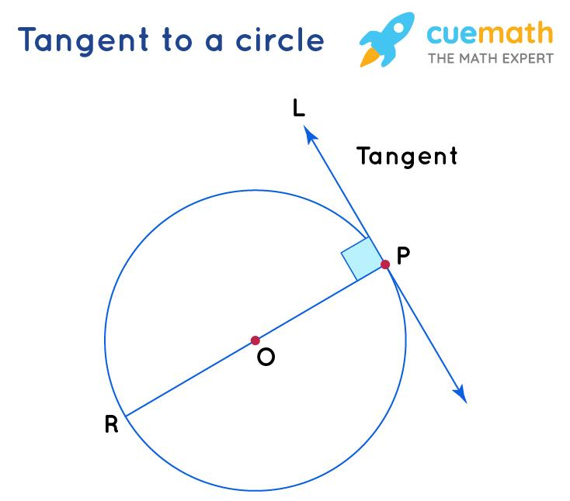
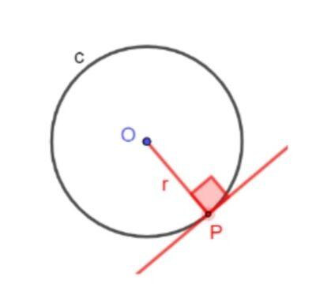

Intersection of Two Circles
# Source: AI Source: Provided by: [Data Path: Persons Table -> ID Column: 1, Name_En Column: Motasem Essam] -> From: [ChatGPT] on [7/25/2026]
Two circles can have exactly one common point when they are externally or internally tangent.
In this case:
$$\boxed{C_{1}∩C_{2}=P}$$
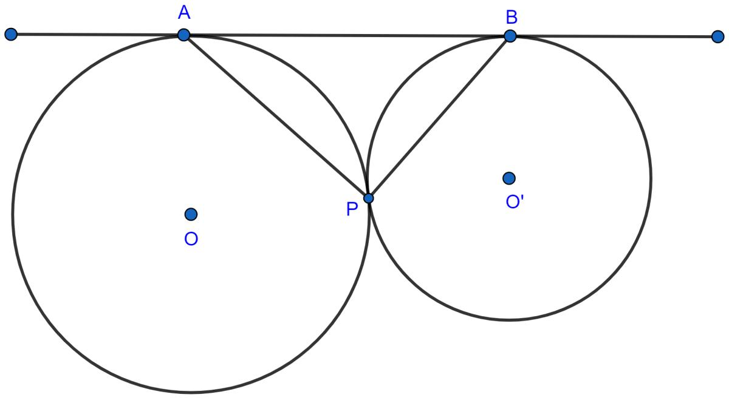
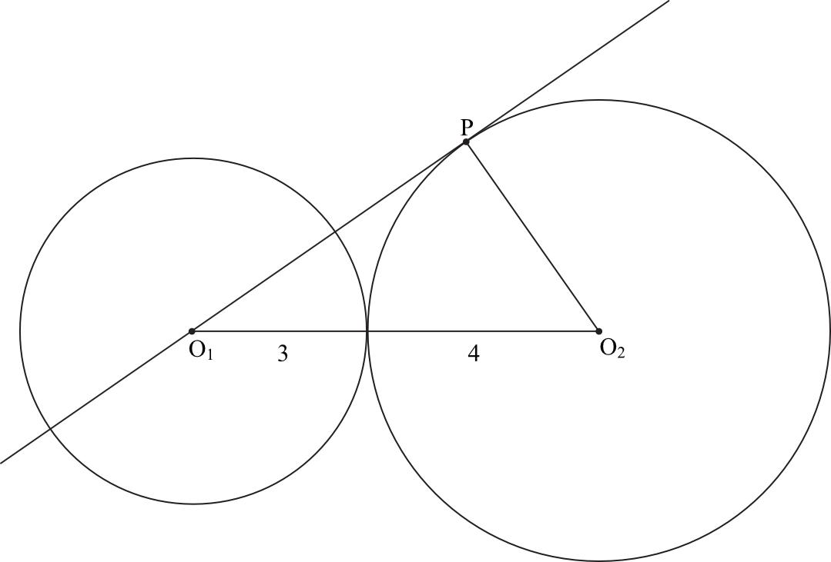
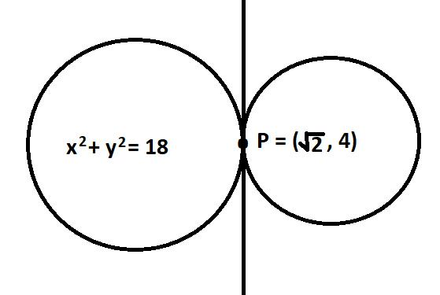

Intersection of Curves
# Source: AI Source: Provided by: [Data Path: Persons Table -> ID Column: 1, Name_En Column: Motasem Essam] -> From: [ChatGPT] on [7/25/2026]
Two curves can cross at exactly one point.
For example:
$$\boxed{C_{1}∩C_{2}=P}$$
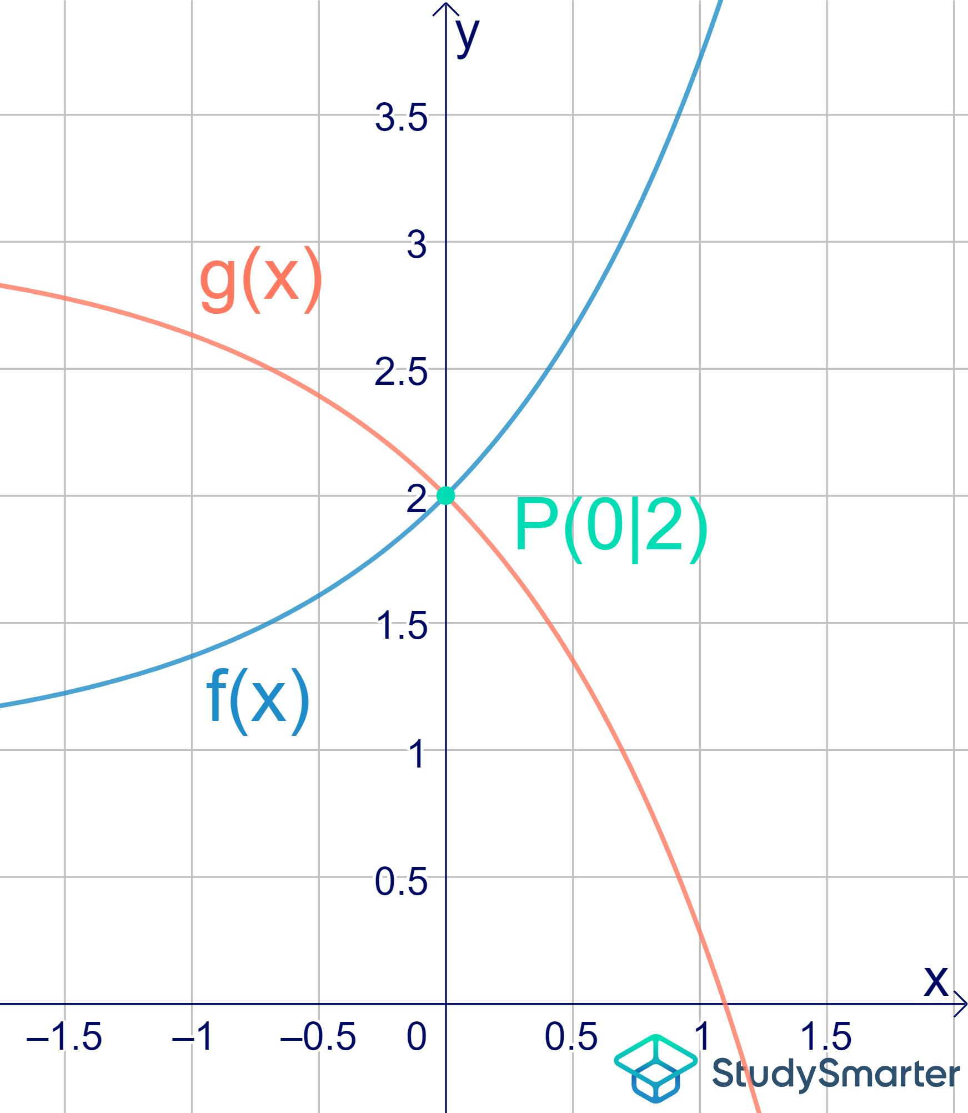
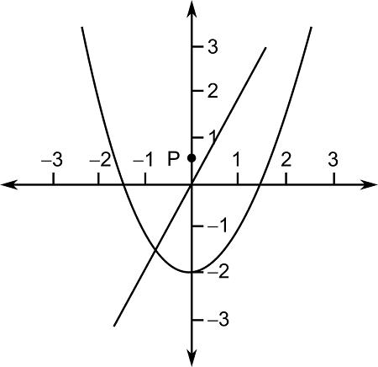
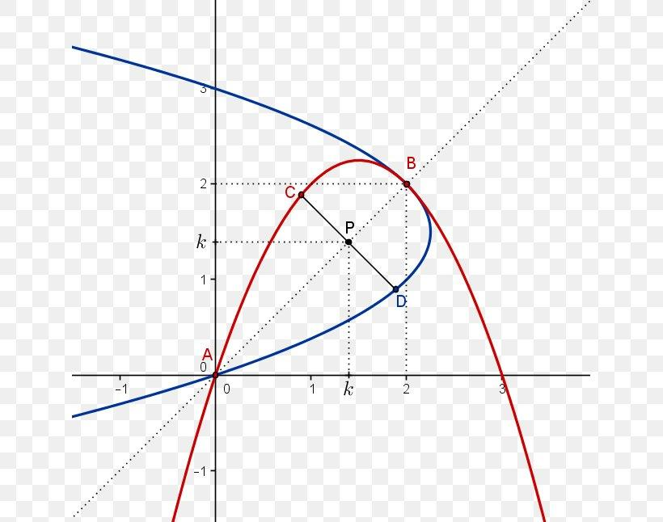
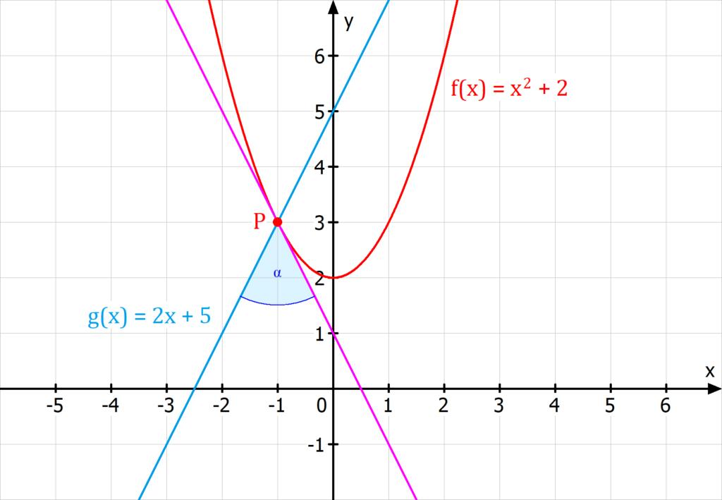
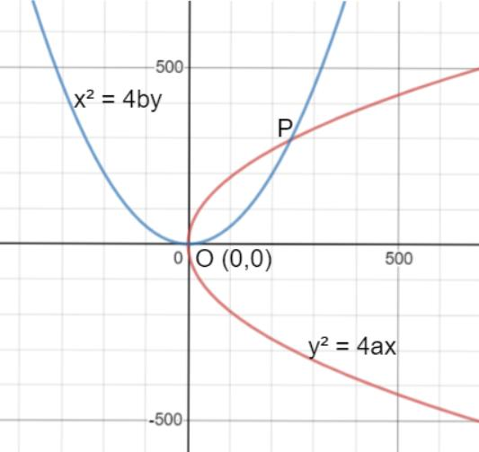
The curves do not need to be straight lines. They can be:
- Circles
- Parabolas
- Ellipses
- Arcs
- Other mathematical curves

Intersection in Coordinate Geometry
# Source: AI Source: Provided by: [Data Path: Persons Table -> ID Column: 1, Name_En Column: Motasem Essam] -> From: [ChatGPT] on [7/25/2026]
In coordinate geometry, a point intersection is represented by an ordered pair:
$$\boxed{P=\left(x,y\right)}$$
For example, consider:
$$y=x+1$$
and:
$$y=-x+5$$
At their intersection:
$$x+1=-x+5$$
Therefore:
$$2x=4 \\ x=2$$
Substitute $x=2$:
$$y=3$$
Thus the point of intersection is:
$$\boxed{P=\left(2,3\right)}$$
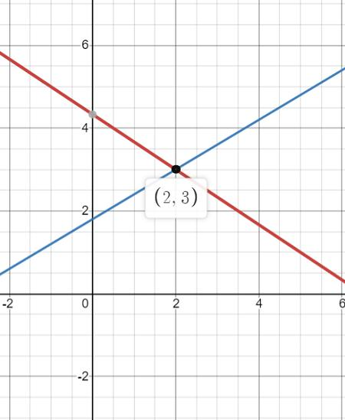
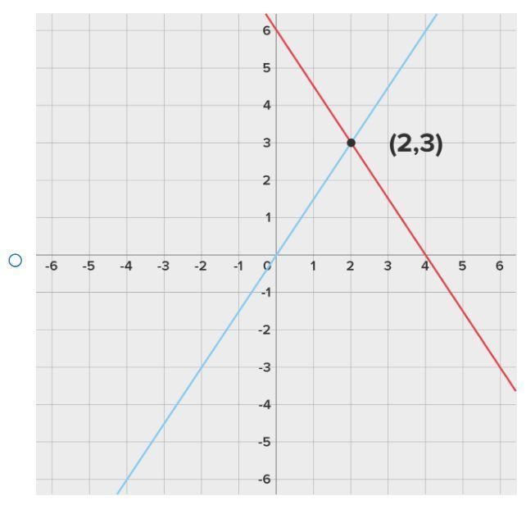
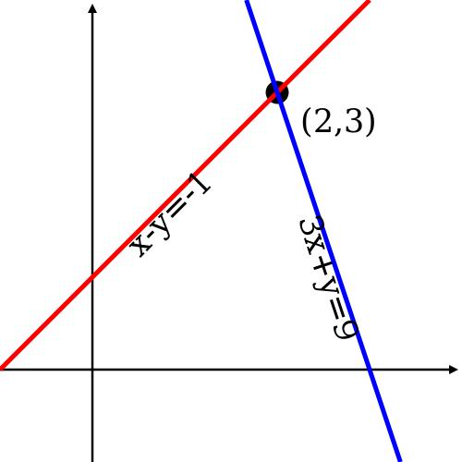
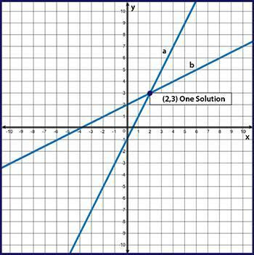
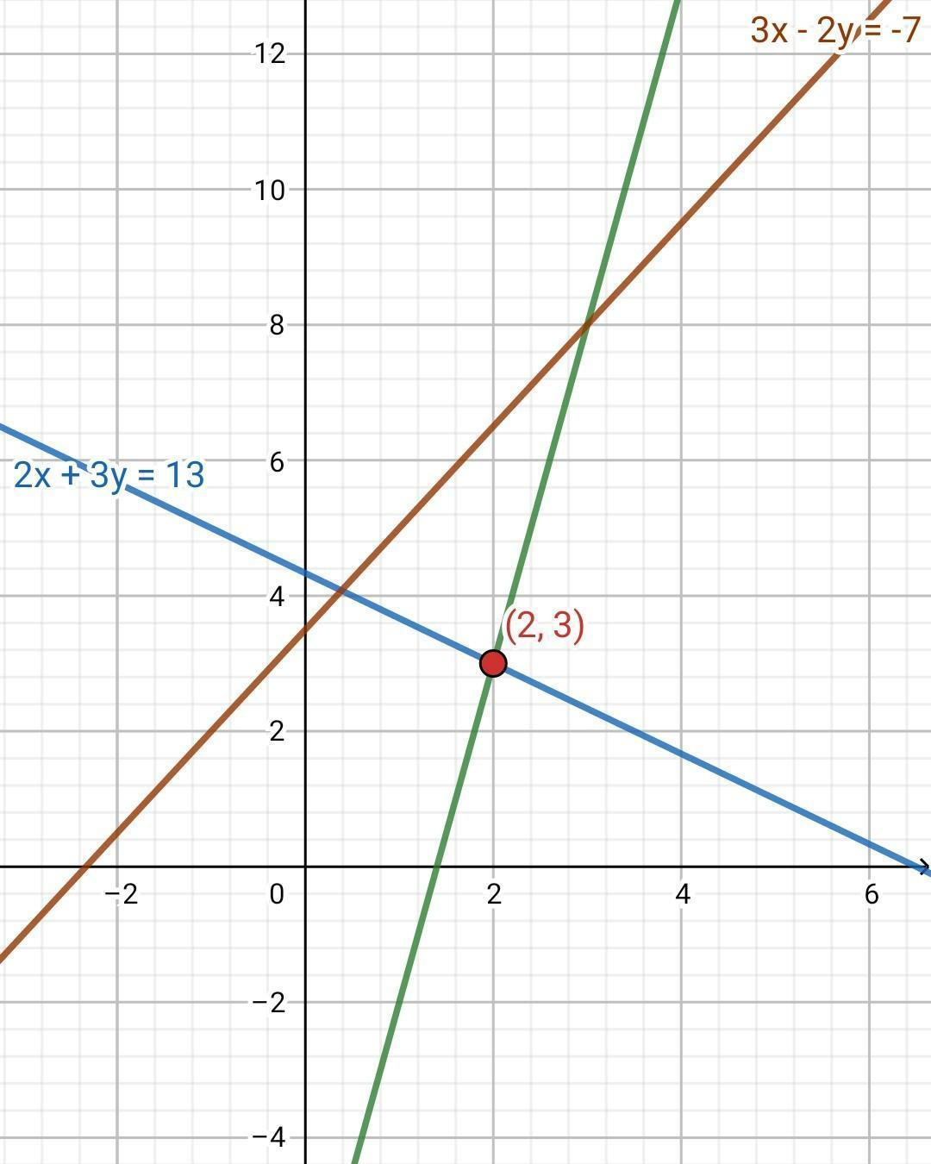
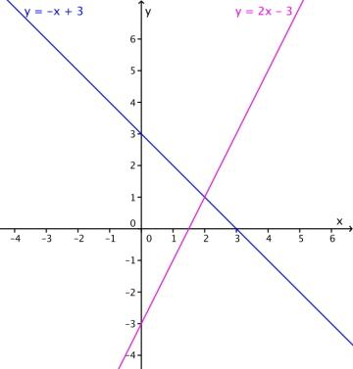

Finding a Point Intersection Algebraically
# Source: AI Source: Provided by: [Data Path: Persons Table -> ID Column: 1, Name_En Column: Motasem Essam] -> From: [ChatGPT] on [7/25/2026]
For two linear equations:
$$y=m_{1}x+b_{1}$$
and:
$$y=m_{2}x+b_{2}$$
the intersection point can be found by setting the equations equal:
$$m_{1}x+b_{1}=m_{2}x+b_{2}$$
Then solve for $x$, followed by $y$.
The resulting point:
$$\boxed{\left(x,y\right)}$$
is the point of intersection.

Point Intersection and Angles
# Source: AI Source: Provided by: [Data Path: Persons Table -> ID Column: 1, Name_En Column: Motasem Essam] -> From: [ChatGPT] on [7/25/2026]
When two lines intersect at a point, they form four angles around that point.
For example:
$$\boxed{P}$$
is the intersection point.
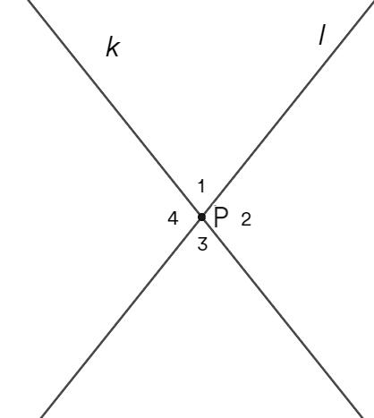
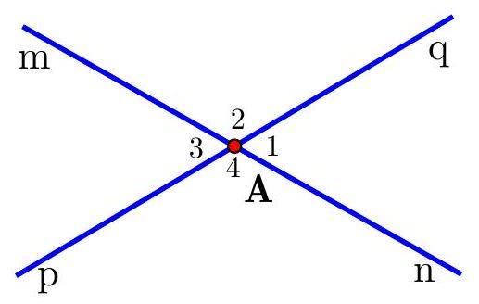
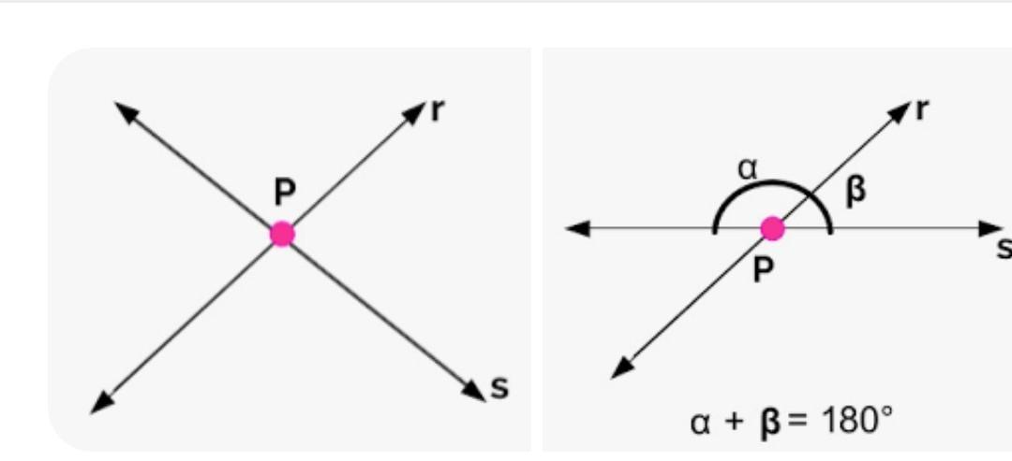
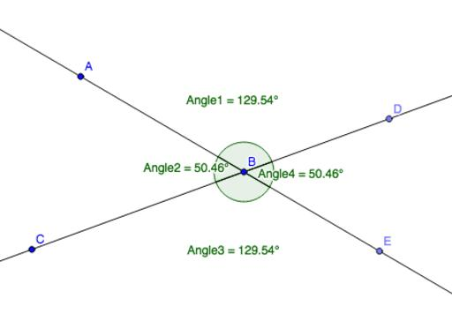
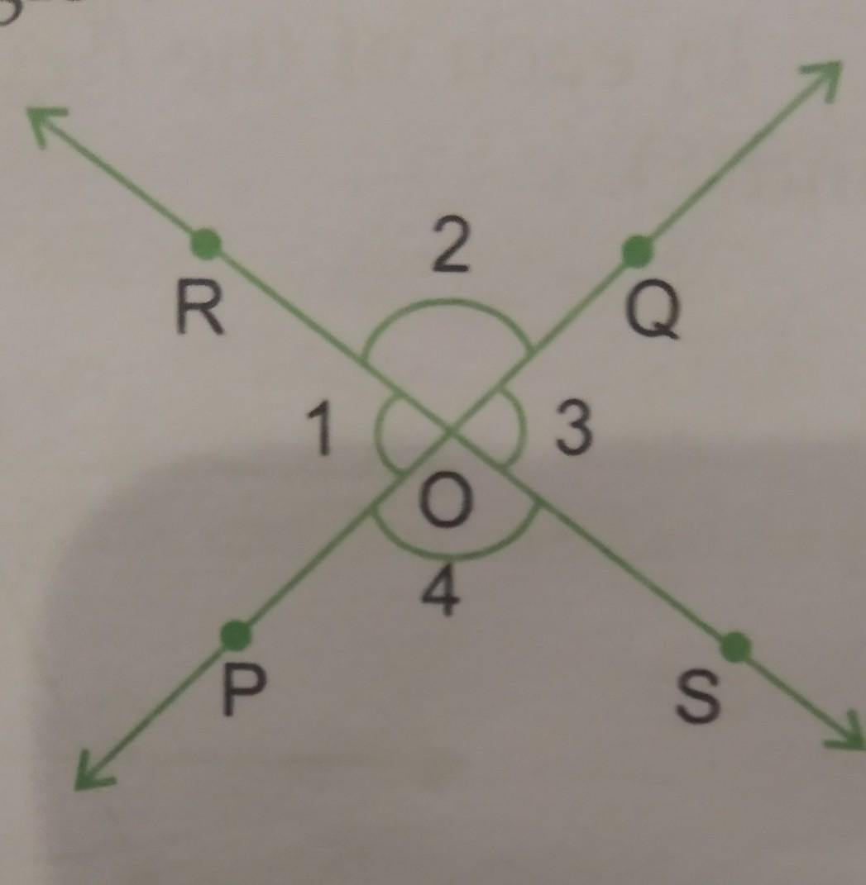
The angles depend on the direction of the two lines.
If the lines are perpendicular:
$$\boxed{{90}^{∘}}$$
If they are not perpendicular, the angles can have other measures.

Point Intersection and Perpendicularity
# Source: AI Source: Provided by: [Data Path: Persons Table -> ID Column: 1, Name_En Column: Motasem Essam] -> From: [ChatGPT] on [7/25/2026]
Perpendicularity is a special case of point intersection.
If two lines intersect at $P$ and form a right angle:
$$\boxed{l_{1}⊥l_{2}}$$
then:
$$\boxed{l_{1}∩l_{2}=P}$$
and:
$$\boxed{∠P={90}^{∘}}$$
Therefore:
$$\boxed{\text{Perpendicularity}=\text{Point Intersection at }{90}^{∘}}$$
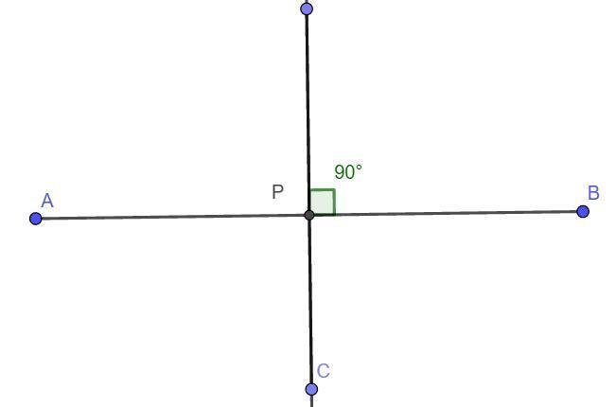
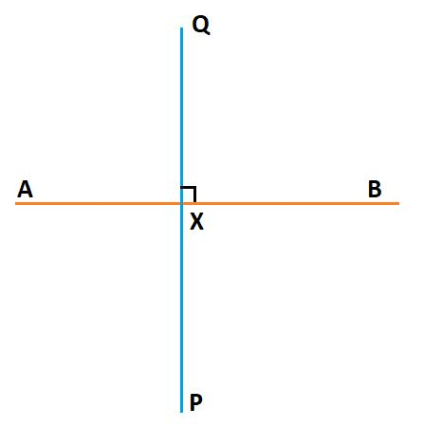
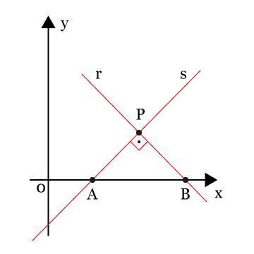

Point Intersection and Parallelism
# Source: AI Source: Provided by: [Data Path: Persons Table -> ID Column: 1, Name_En Column: Motasem Essam] -> From: [ChatGPT] on [7/25/2026]
Point intersection is different from parallelism.
Point Intersection
Two objects share exactly one point:
$$\boxed{A∩B=P}$$
Parallel Lines
Two distinct parallel lines have no common point:
$$\boxed{A∩B=∅}$$
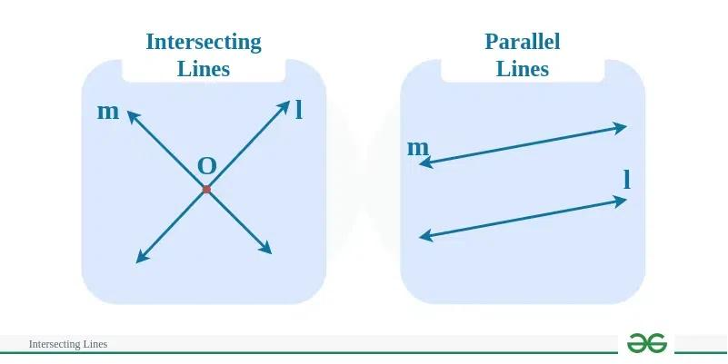
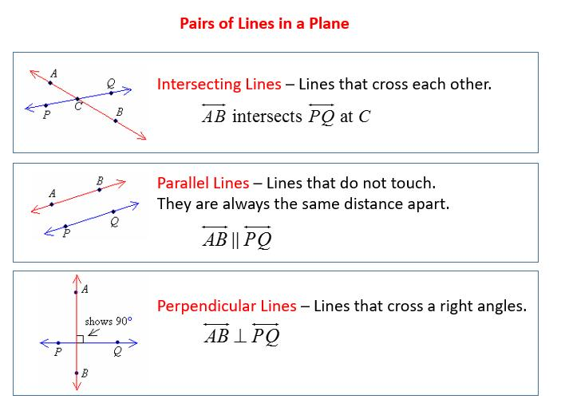
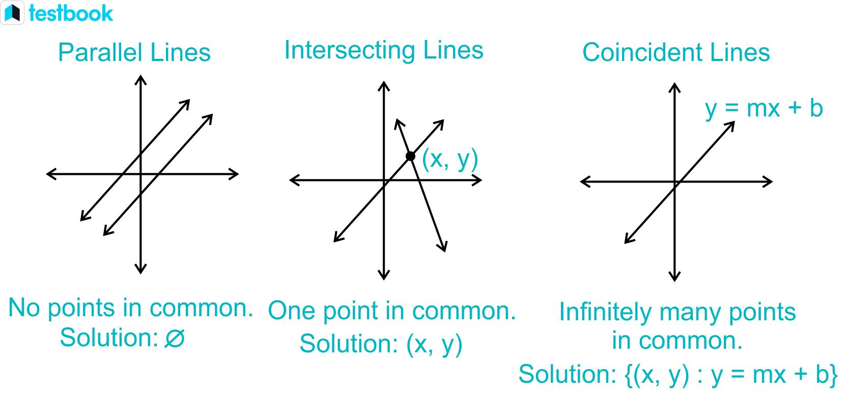

Point Intersection in Polygons
# Source: AI Source: Provided by: [Data Path: Persons Table -> ID Column: 1, Name_En Column: Motasem Essam] -> From: [ChatGPT] on [7/25/2026]
Point intersections can occur where sides or diagonals of polygons meet.
For example, the diagonals of a rectangle intersect at one point:
$$\boxed{AC∩BD=O}$$
where $O$ is the intersection point.
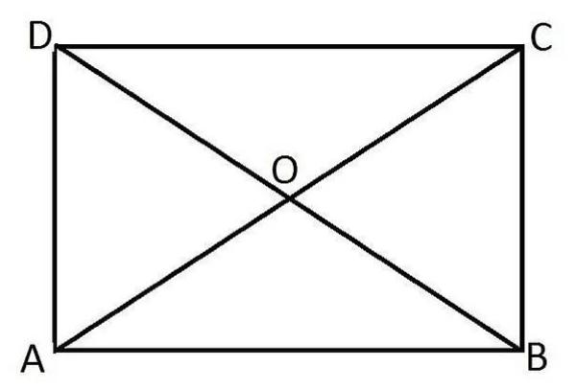
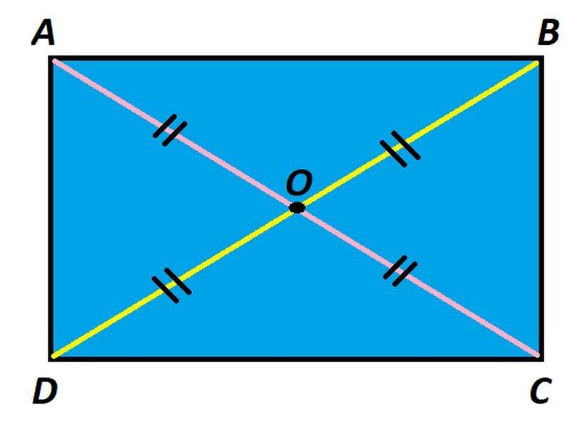
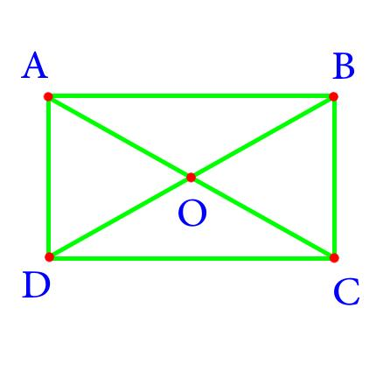
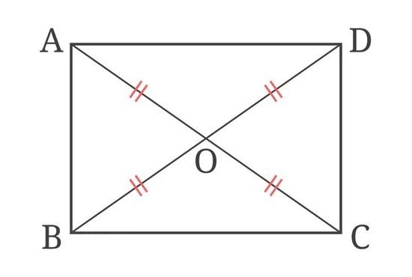

Point Intersection of Polygon Sides
# Source: AI Source: Provided by: [Data Path: Persons Table -> ID Column: 1, Name_En Column: Motasem Essam] -> From: [ChatGPT] on [7/25/2026]
Two non-adjacent sides of different polygons may cross at a single point.
In geometric diagrams, these intersection points can be used to:
- Define new vertices.
- Construct new shapes.
- Determine angles.
- Divide regions.
- Analyze geometric relationships.

Point Intersection in Triangles
# Source: AI Source: Provided by: [Data Path: Persons Table -> ID Column: 1, Name_En Column: Motasem Essam] -> From: [ChatGPT] on [7/25/2026]
The important centers of a triangle are created through intersections of geometric lines.
For example, the medians of a triangle intersect at the centroid.
If the medians meet at $G$:
$$\boxed{m_{1}∩m_{2}∩m_{3}=G}$$
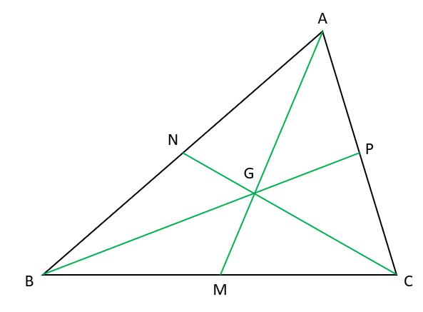
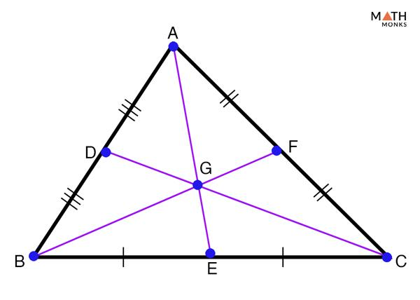
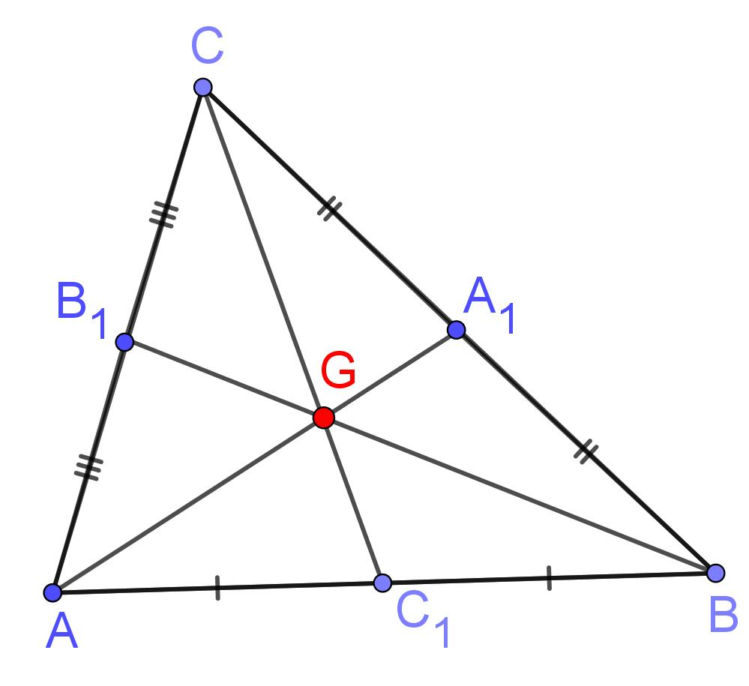
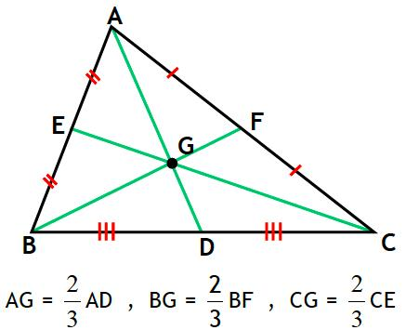
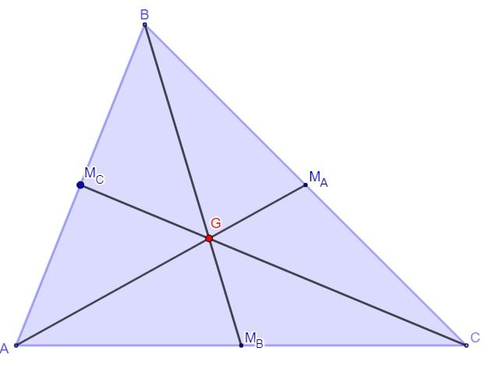
Similarly, other triangle centers are defined by intersections of lines:
- Centroid — intersection of medians.
- Incenter — intersection of angle bisectors.
- Circumcenter — intersection of perpendicular bisectors.
- Orthocenter — intersection of altitudes.
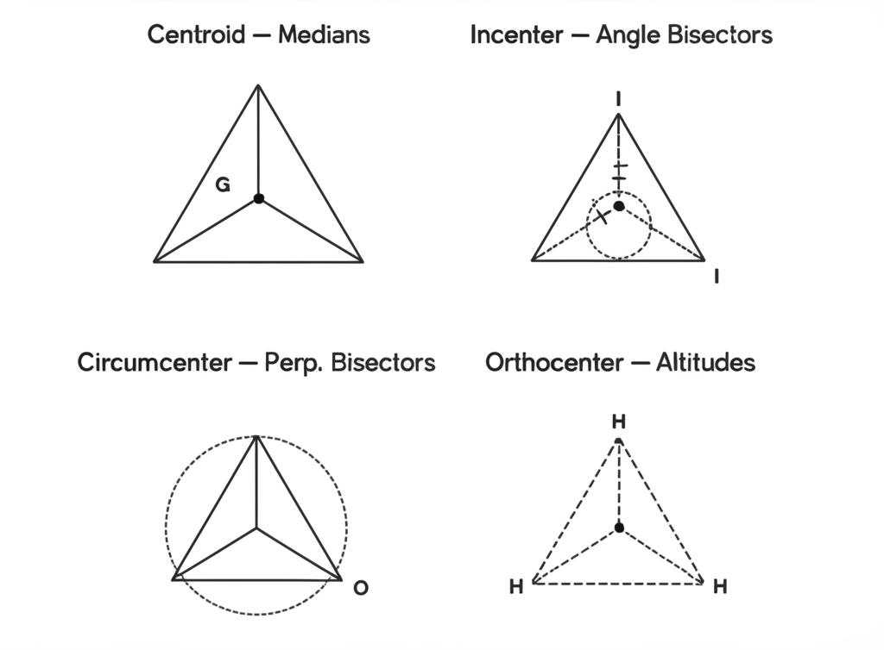
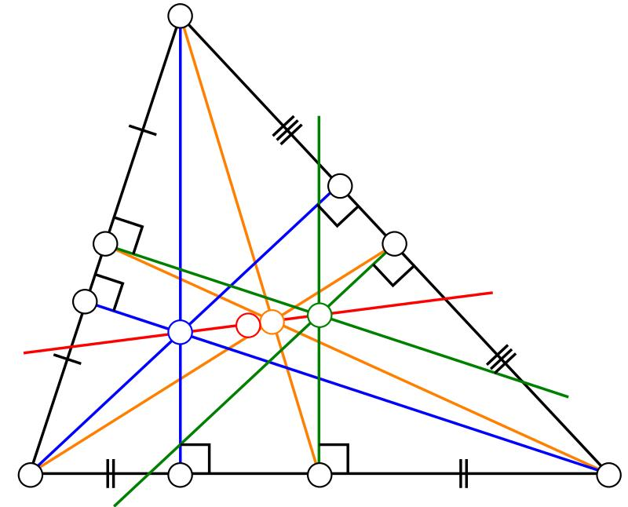
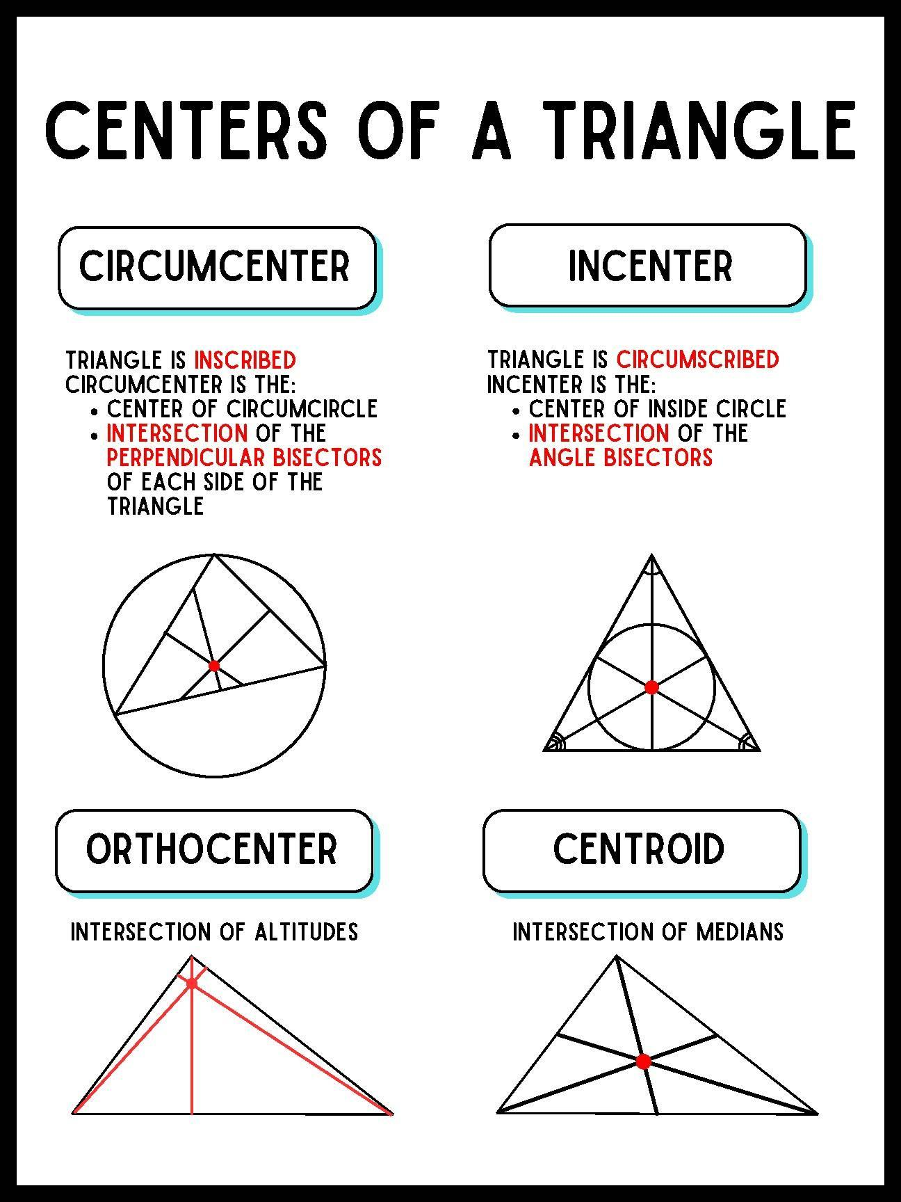
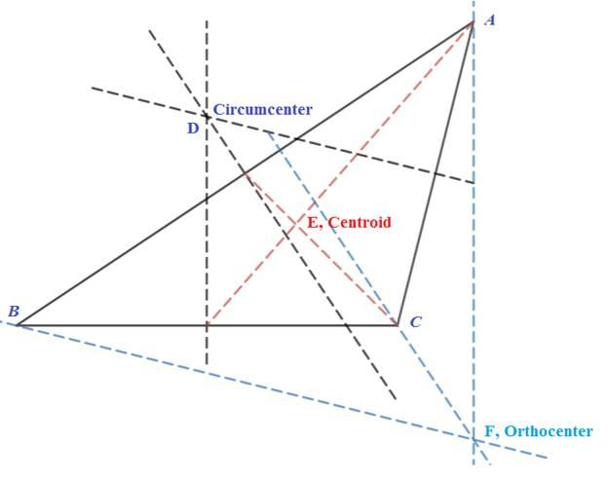
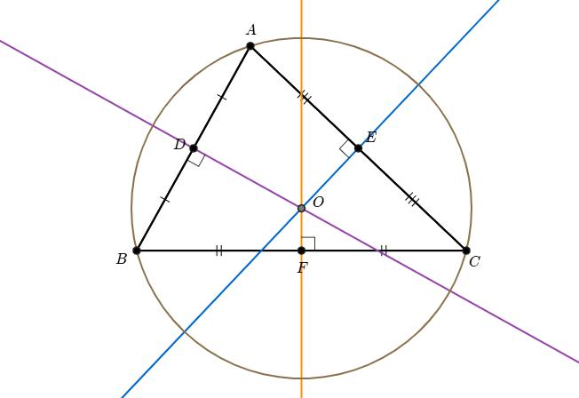

Point Intersection in Graphs
# Source: AI Source: Provided by: [Data Path: Persons Table -> ID Column: 1, Name_En Column: Motasem Essam] -> From: [ChatGPT] on [7/25/2026]
In graphs and coordinate systems, the intersection of two lines represents a common solution to their equations.
For example:
$$\left\{\begin{aligned}y=x+1 \\ y=-x+5\end{aligned}\right.$$
has the solution:
$$\boxed{\left(2,3\right)}$$
Thus:
$$\boxed{\left(2,3\right)}$$
is the point where the two graphs intersect.

Point Intersection in Architecture
# Source: AI Source: Provided by: [Data Path: Persons Table -> ID Column: 1, Name_En Column: Motasem Essam] -> From: [ChatGPT] on [7/25/2026]
Point intersections appear where architectural elements meet.
Examples:
- Walls meeting at corners.
- Beams crossing.
- Grid lines crossing.
- Structural members meeting.
- Road layouts.
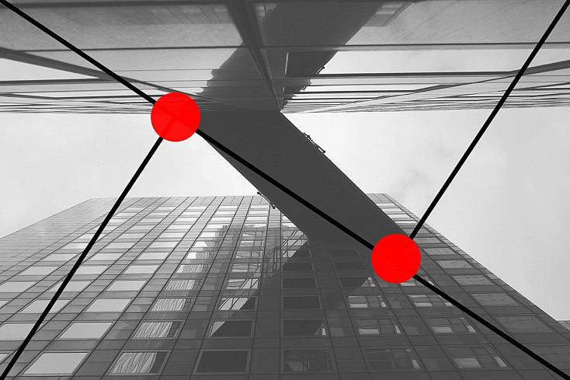
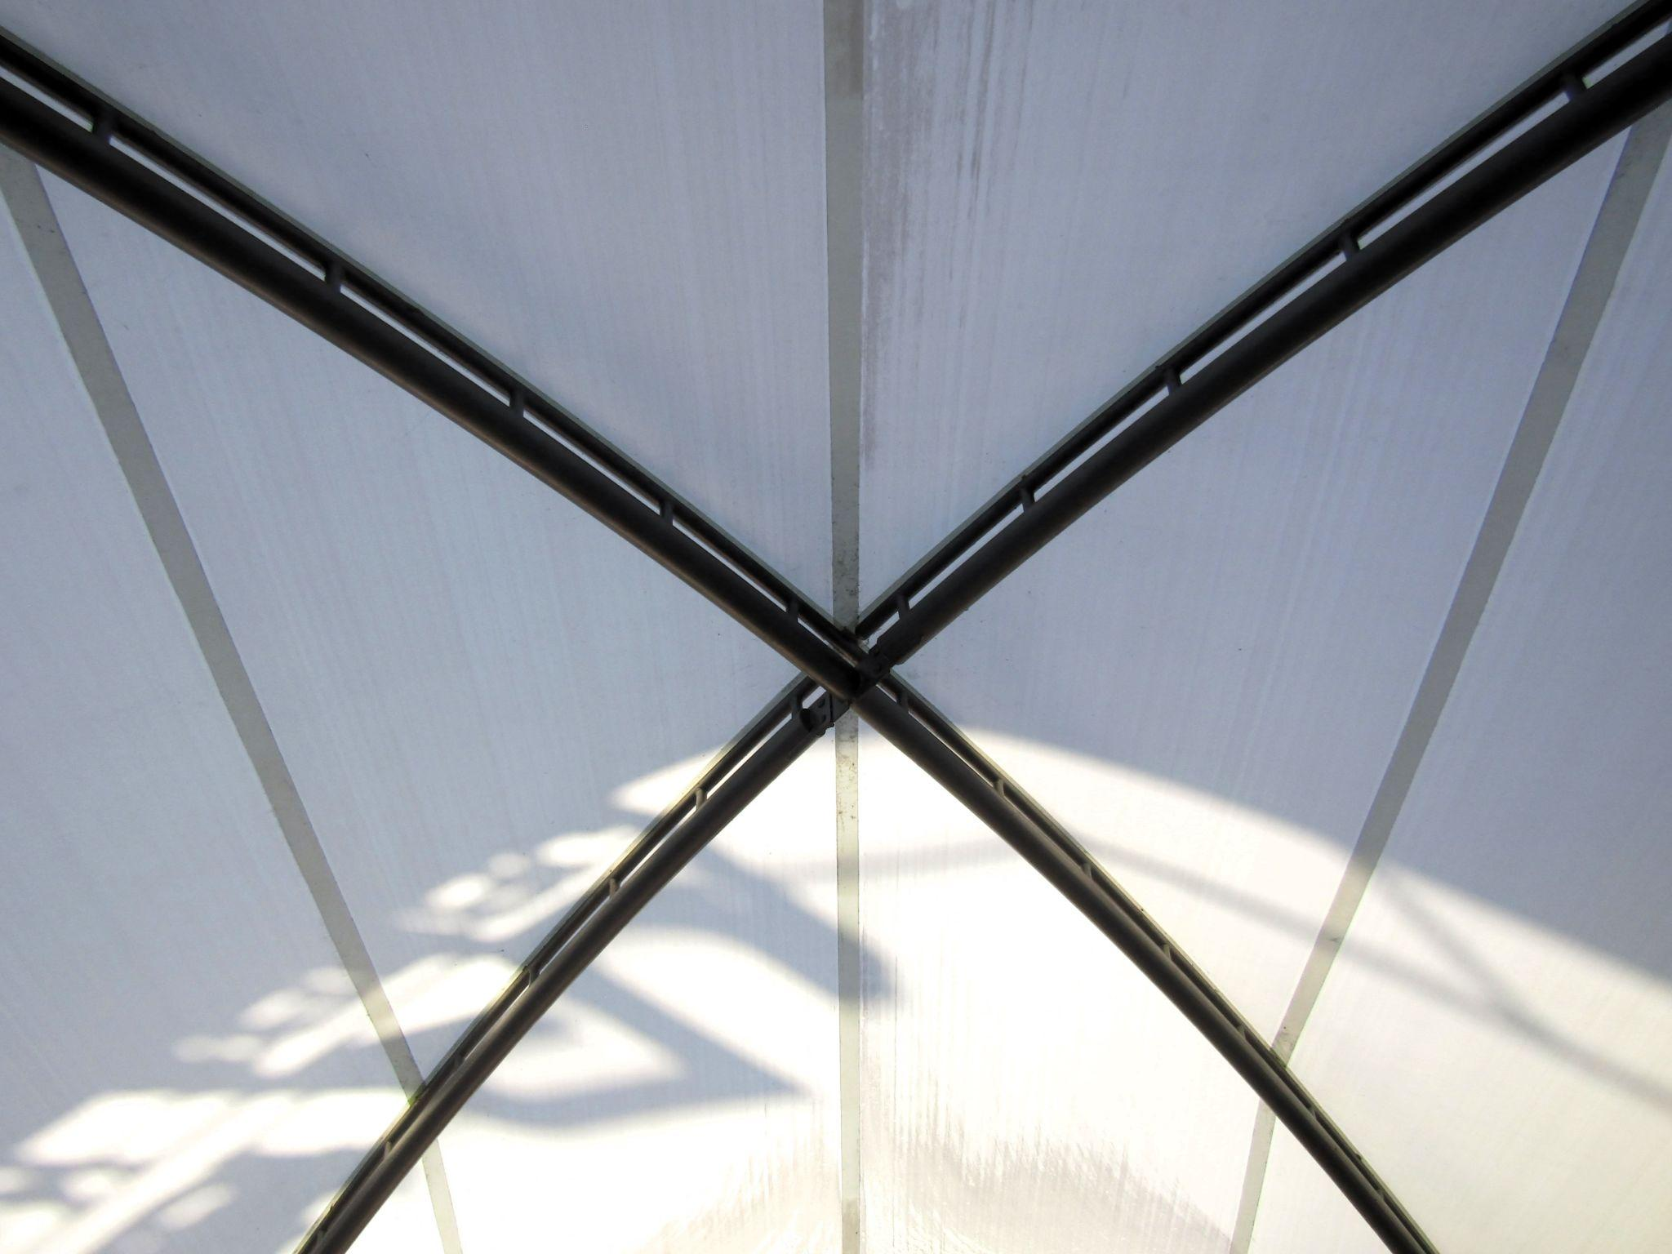
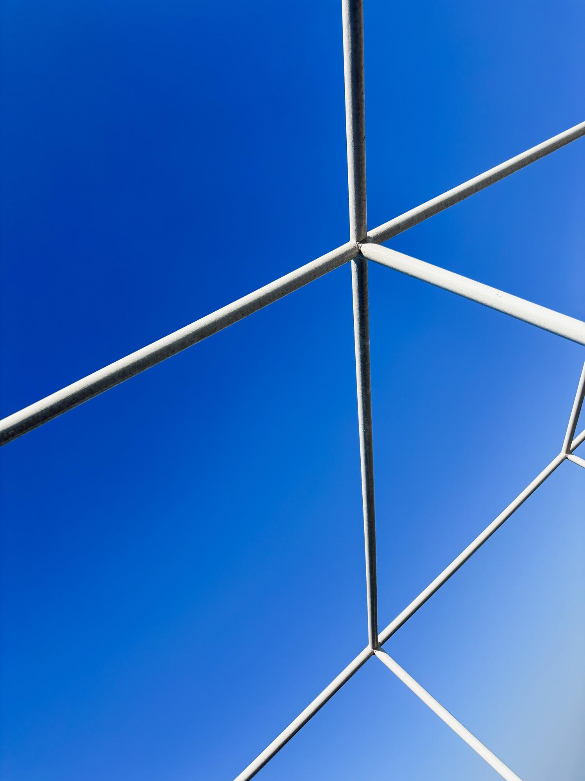
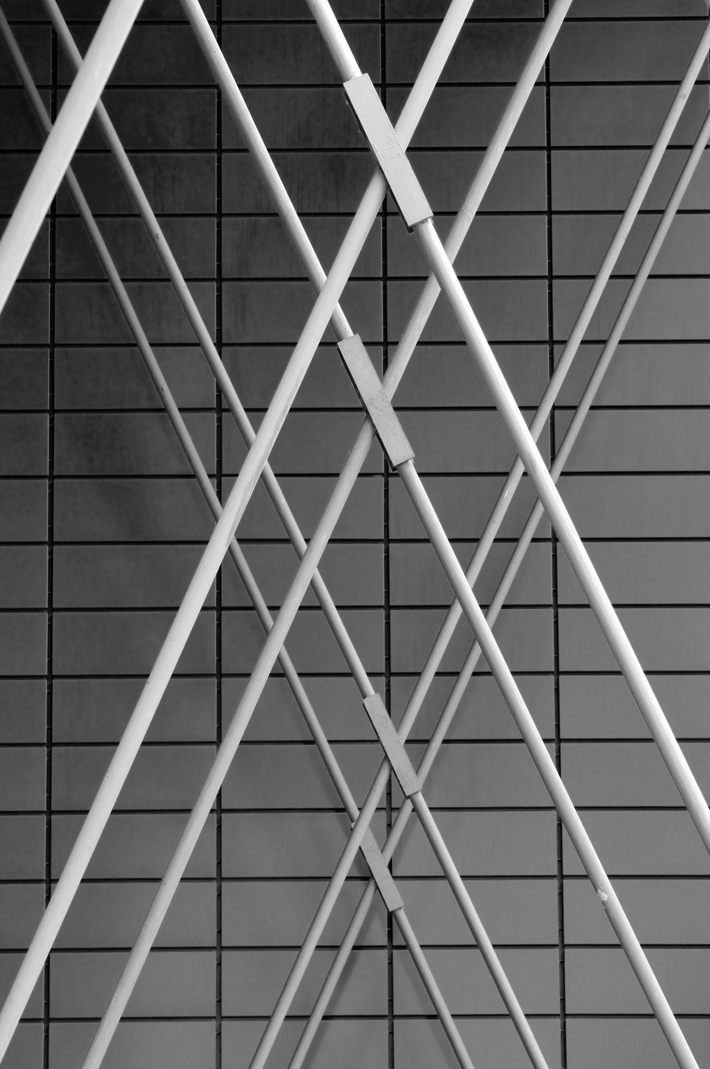
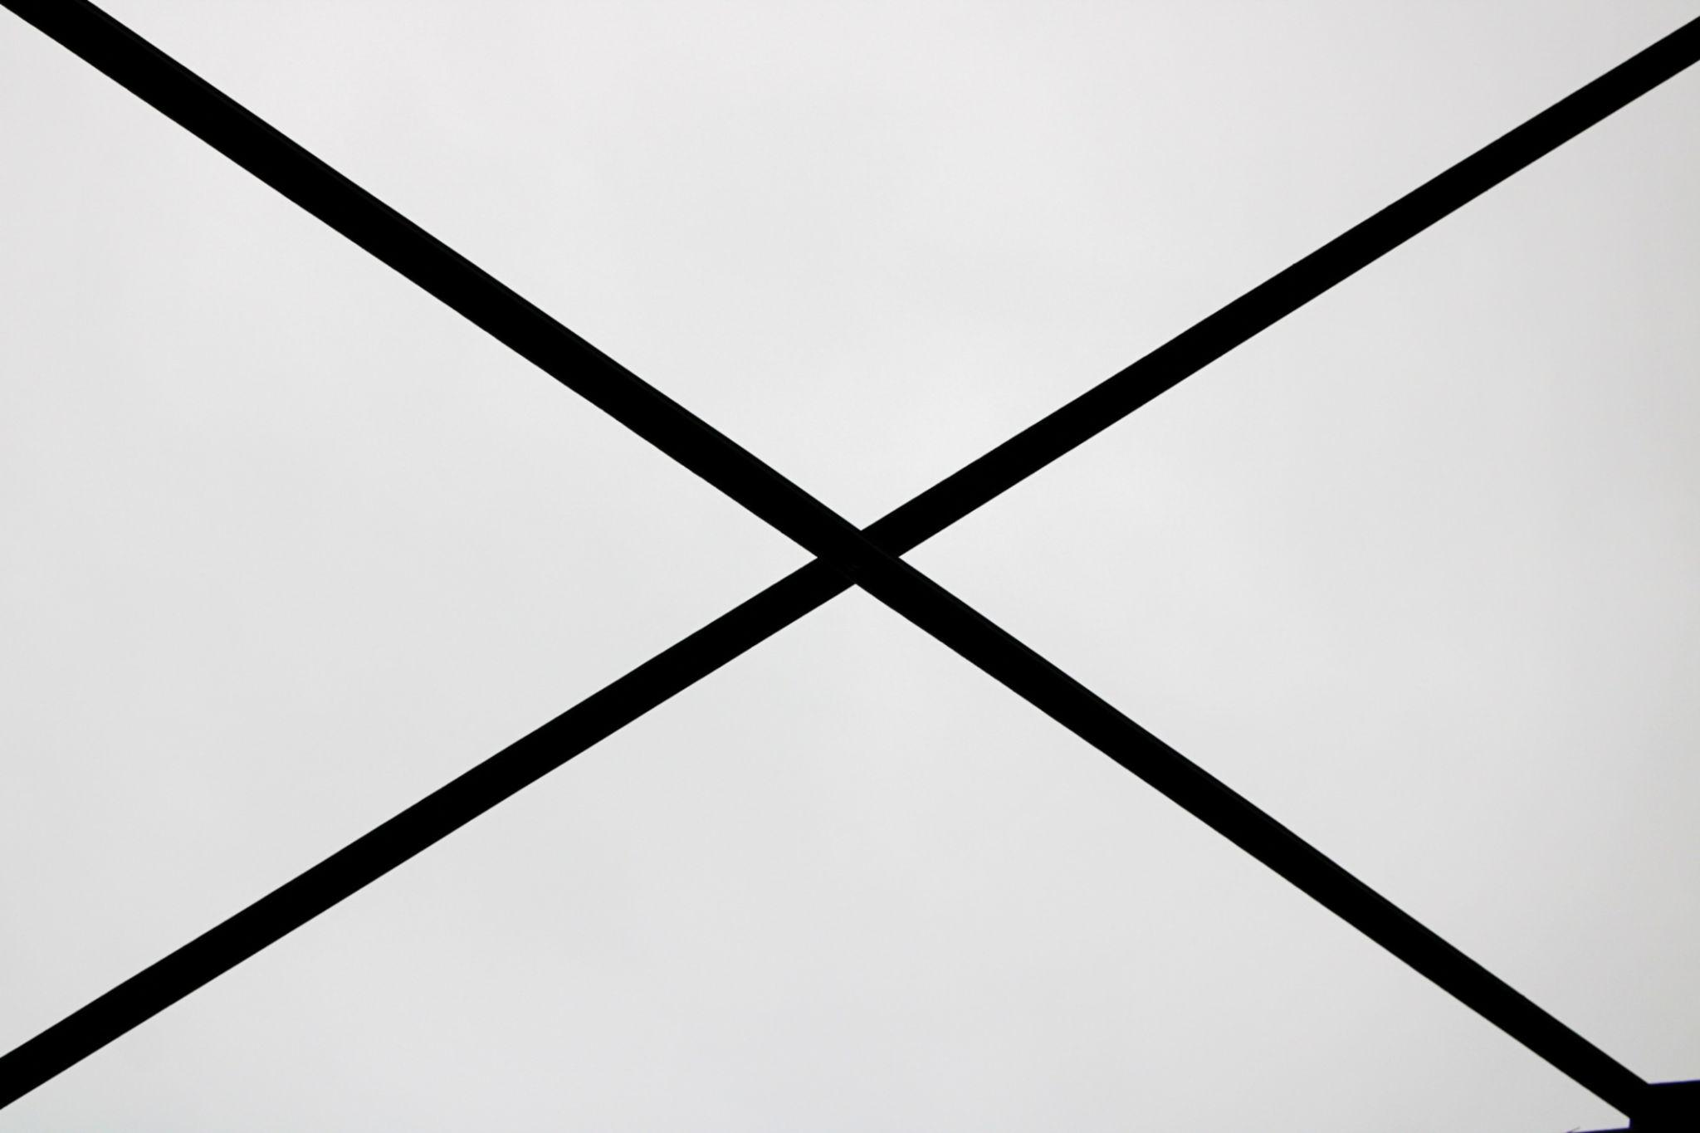

Point Intersection in Engineering
# Source: AI Source: Provided by: [Data Path: Persons Table -> ID Column: 1, Name_En Column: Motasem Essam] -> From: [ChatGPT] on [7/25/2026]
Engineers use intersection points to determine:
- Connection points.
- Structural joints.
- Mechanical contacts.
- Component locations.
- Road crossings.
- CAD geometry.
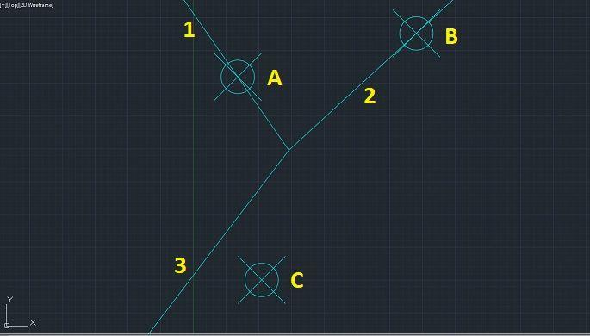
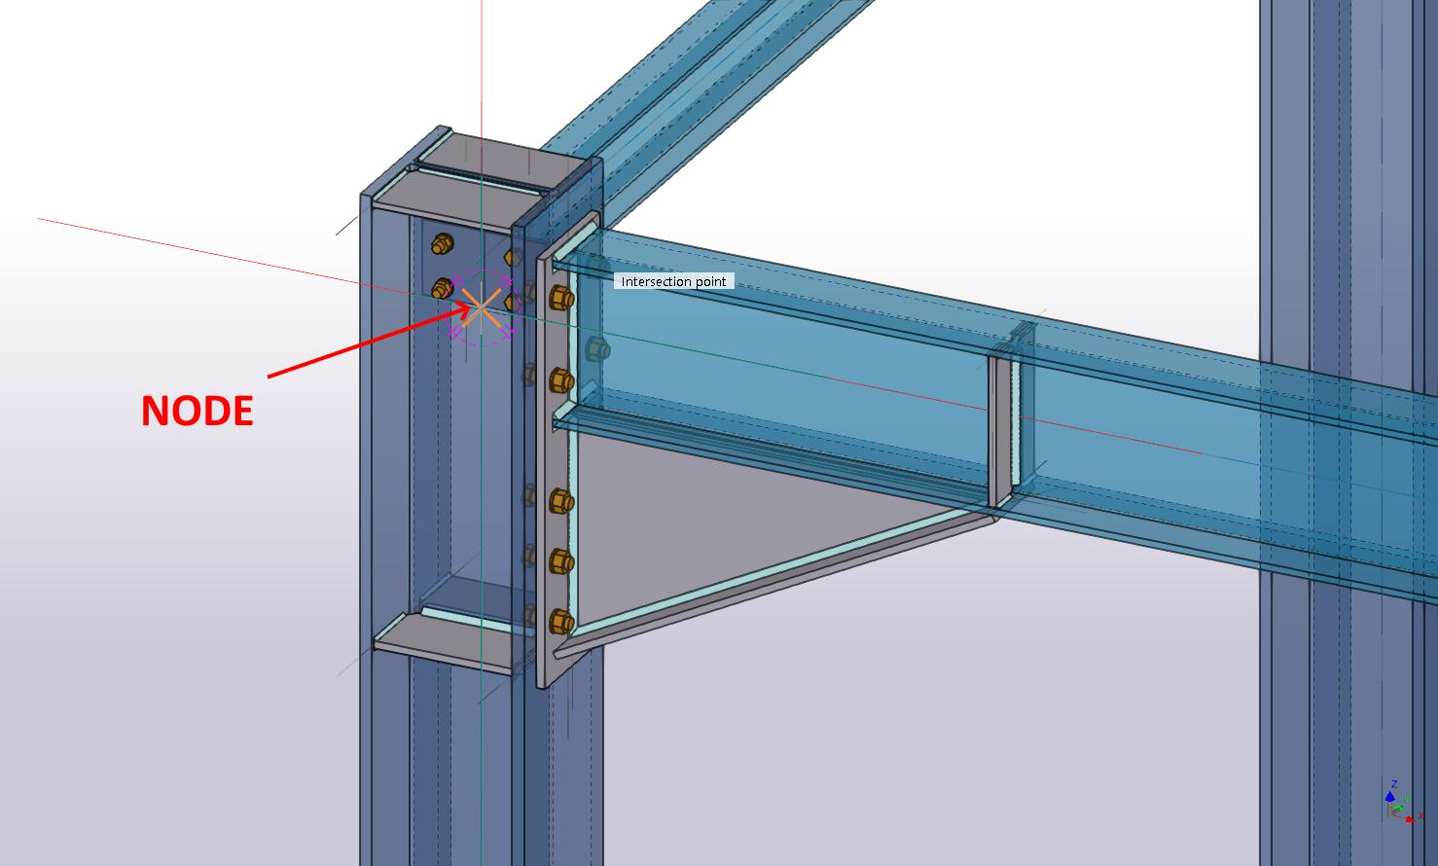
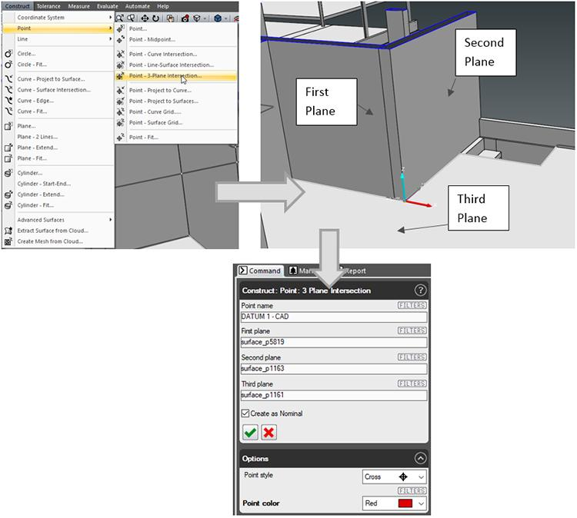
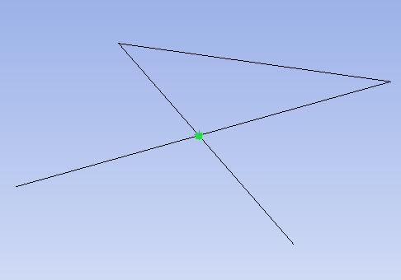
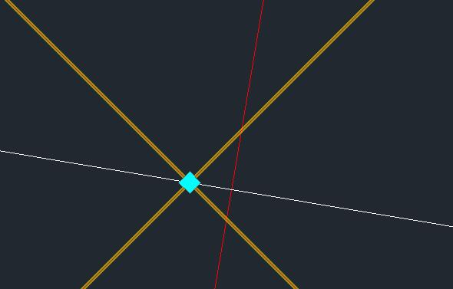
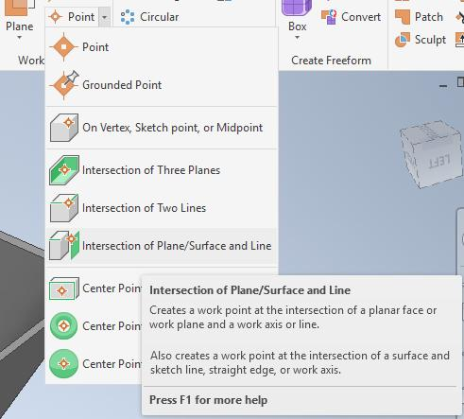
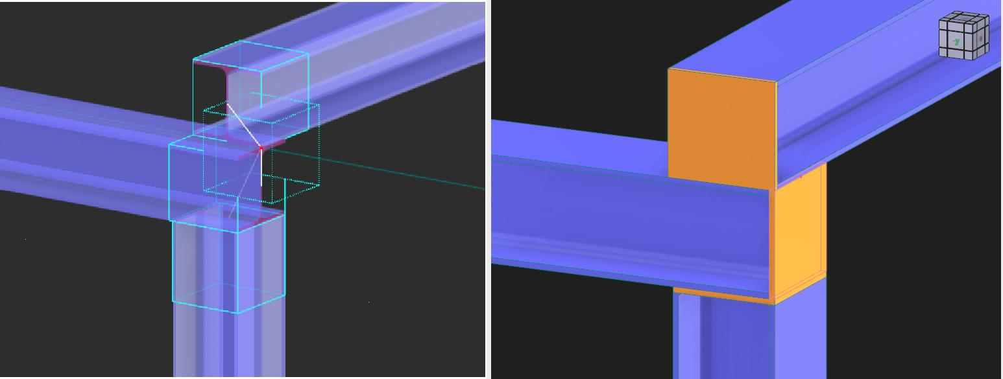

Point Intersection in Surveying
# Source: AI Source: Provided by: [Data Path: Persons Table -> ID Column: 1, Name_En Column: Motasem Essam] -> From: [ChatGPT] on [7/25/2026]
Surveyors can determine a location by finding the intersection of measured lines.
For example, if two known directions point toward the same location, their intersection can identify an unknown point.
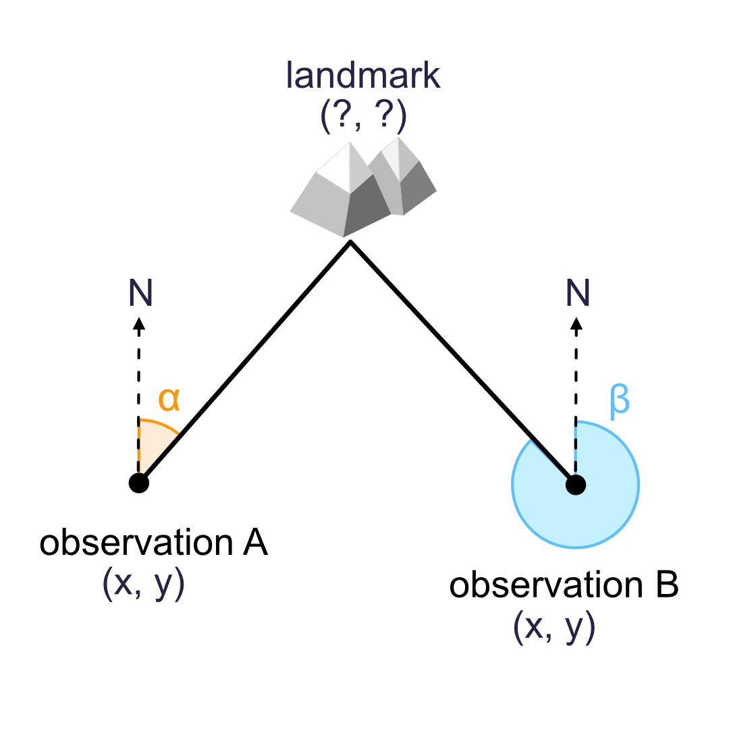
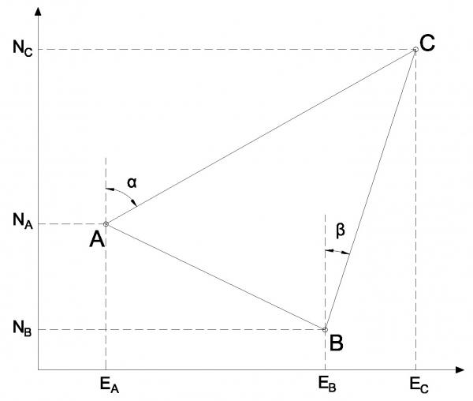
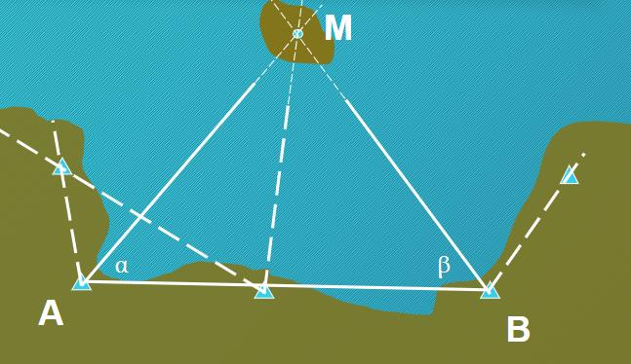
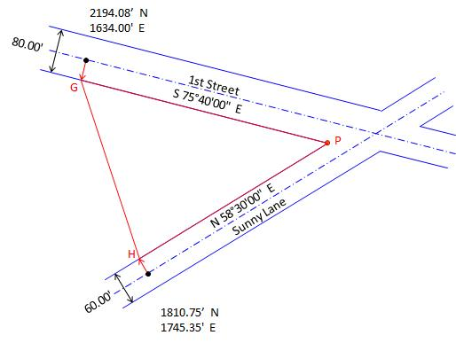

Point Intersection in Computer Graphics
# Source: AI Source: Provided by: [Data Path: Persons Table -> ID Column: 1, Name_En Column: Motasem Essam] -> From: [ChatGPT] on [7/25/2026]
Computer graphics frequently calculate intersections between:
- Lines.
- Rays.
- Polygons.
- Circles.
- Curves.
- Surfaces.
For example, a ray from a camera can intersect a polygon at a single point.
This is important in:
- 3D rendering.
- Ray tracing.
- Collision detection.
- Computer-aided design.
- Geometric modeling.
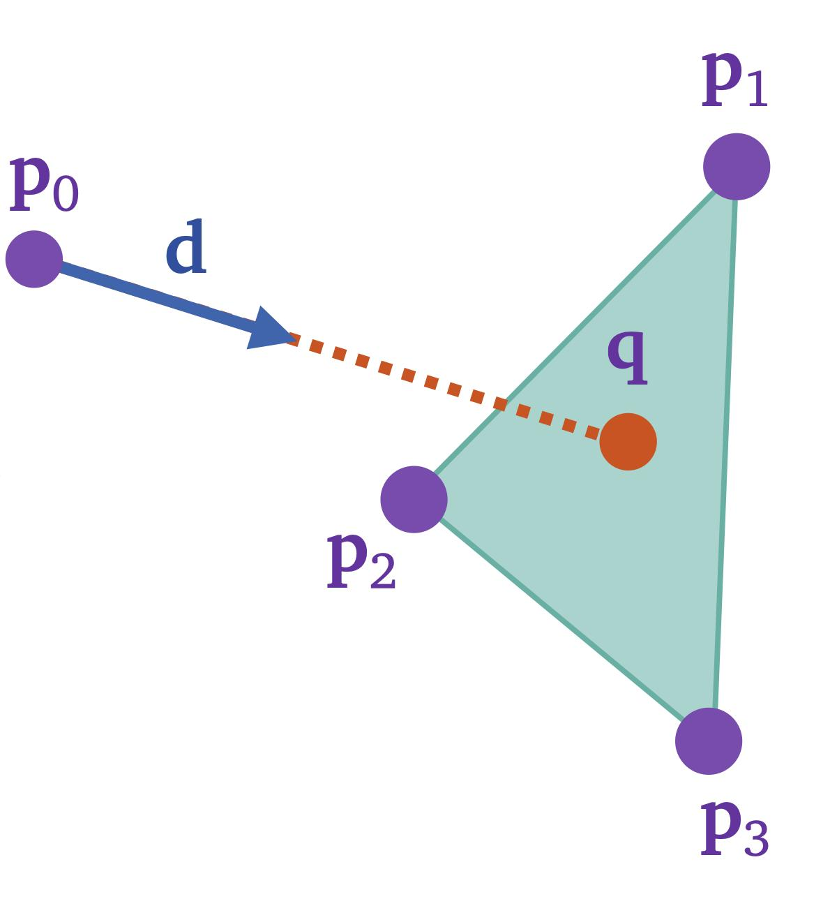
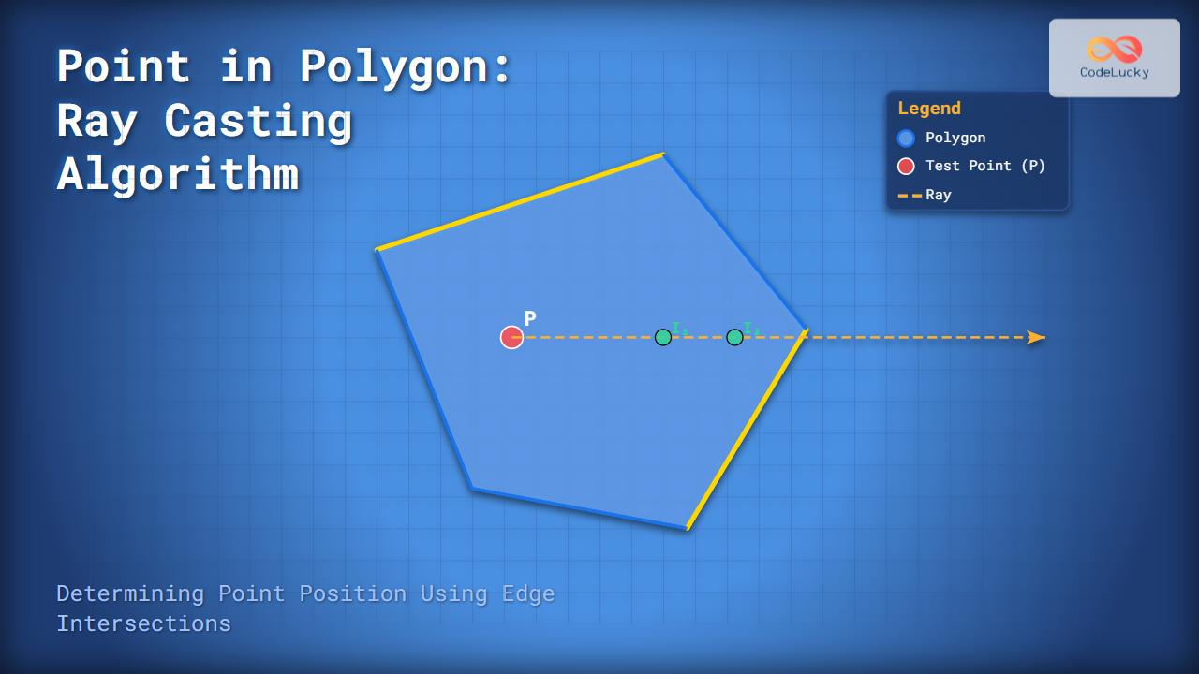
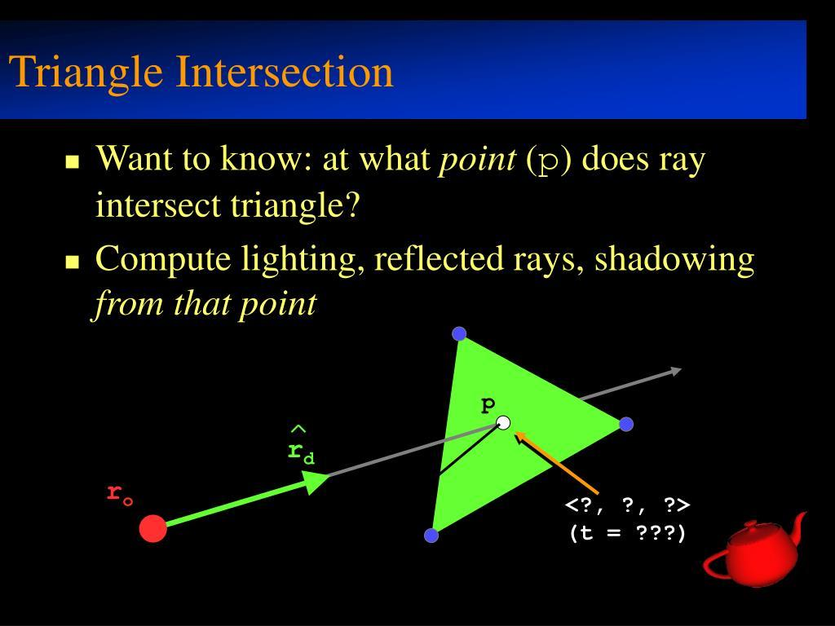
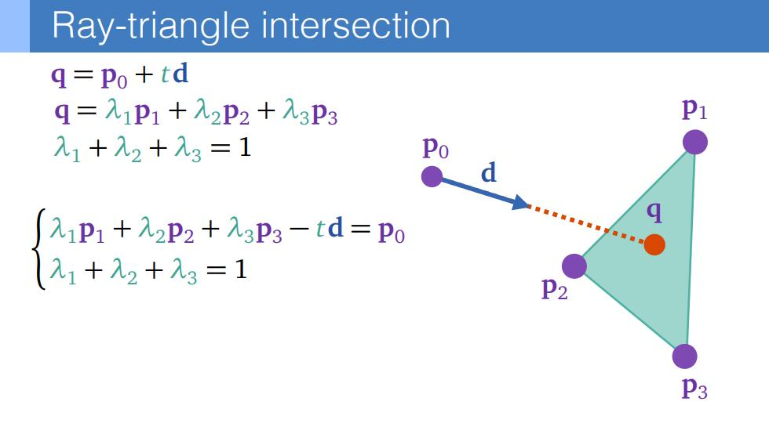
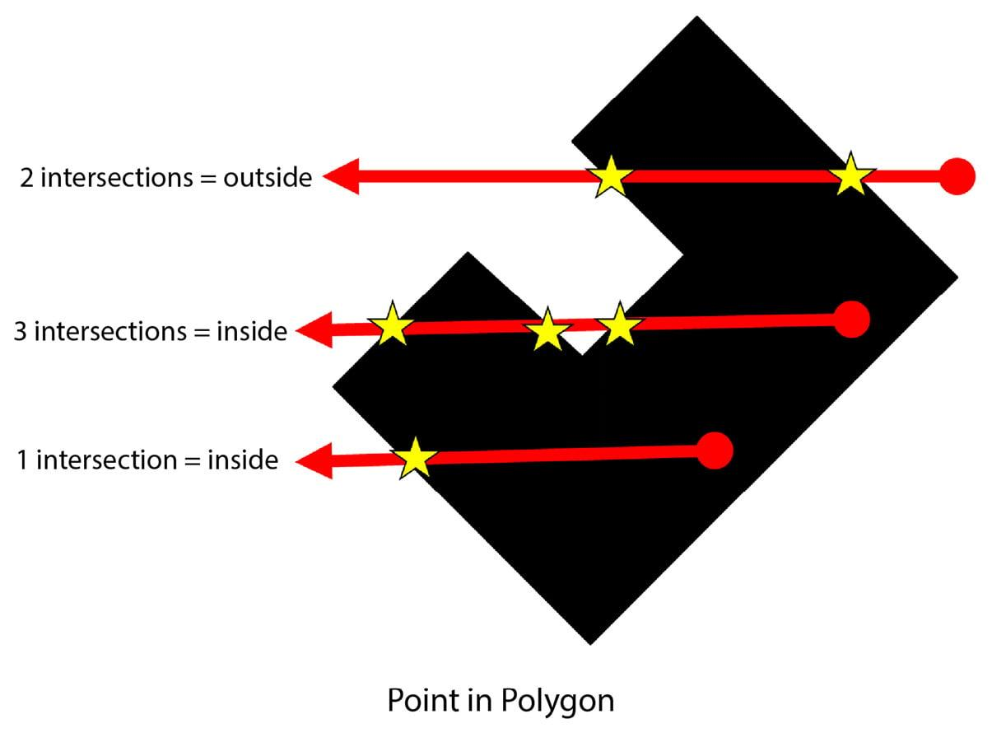

Real-World Examples
# Source: AI Source: Provided by: [Data Path: Persons Table -> ID Column: 1, Name_En Column: Motasem Essam] -> From: [ChatGPT] on [7/25/2026]
Point intersections can be seen in:
- Two roads crossing.
- Two straight lines crossing on a map.
- Two walls meeting at a corner.
- Two beams meeting at a joint.
- A tangent touching a circular object.
- Two paths crossing.
- Two railway tracks crossing.
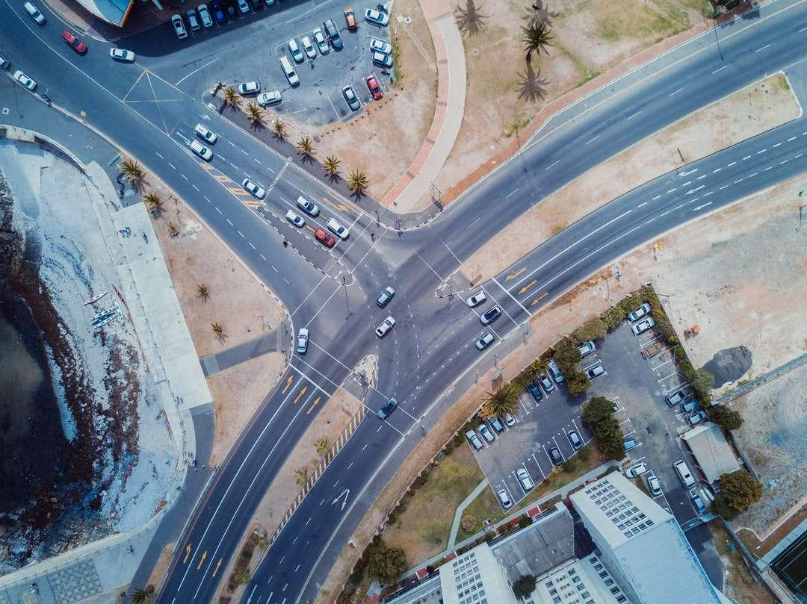
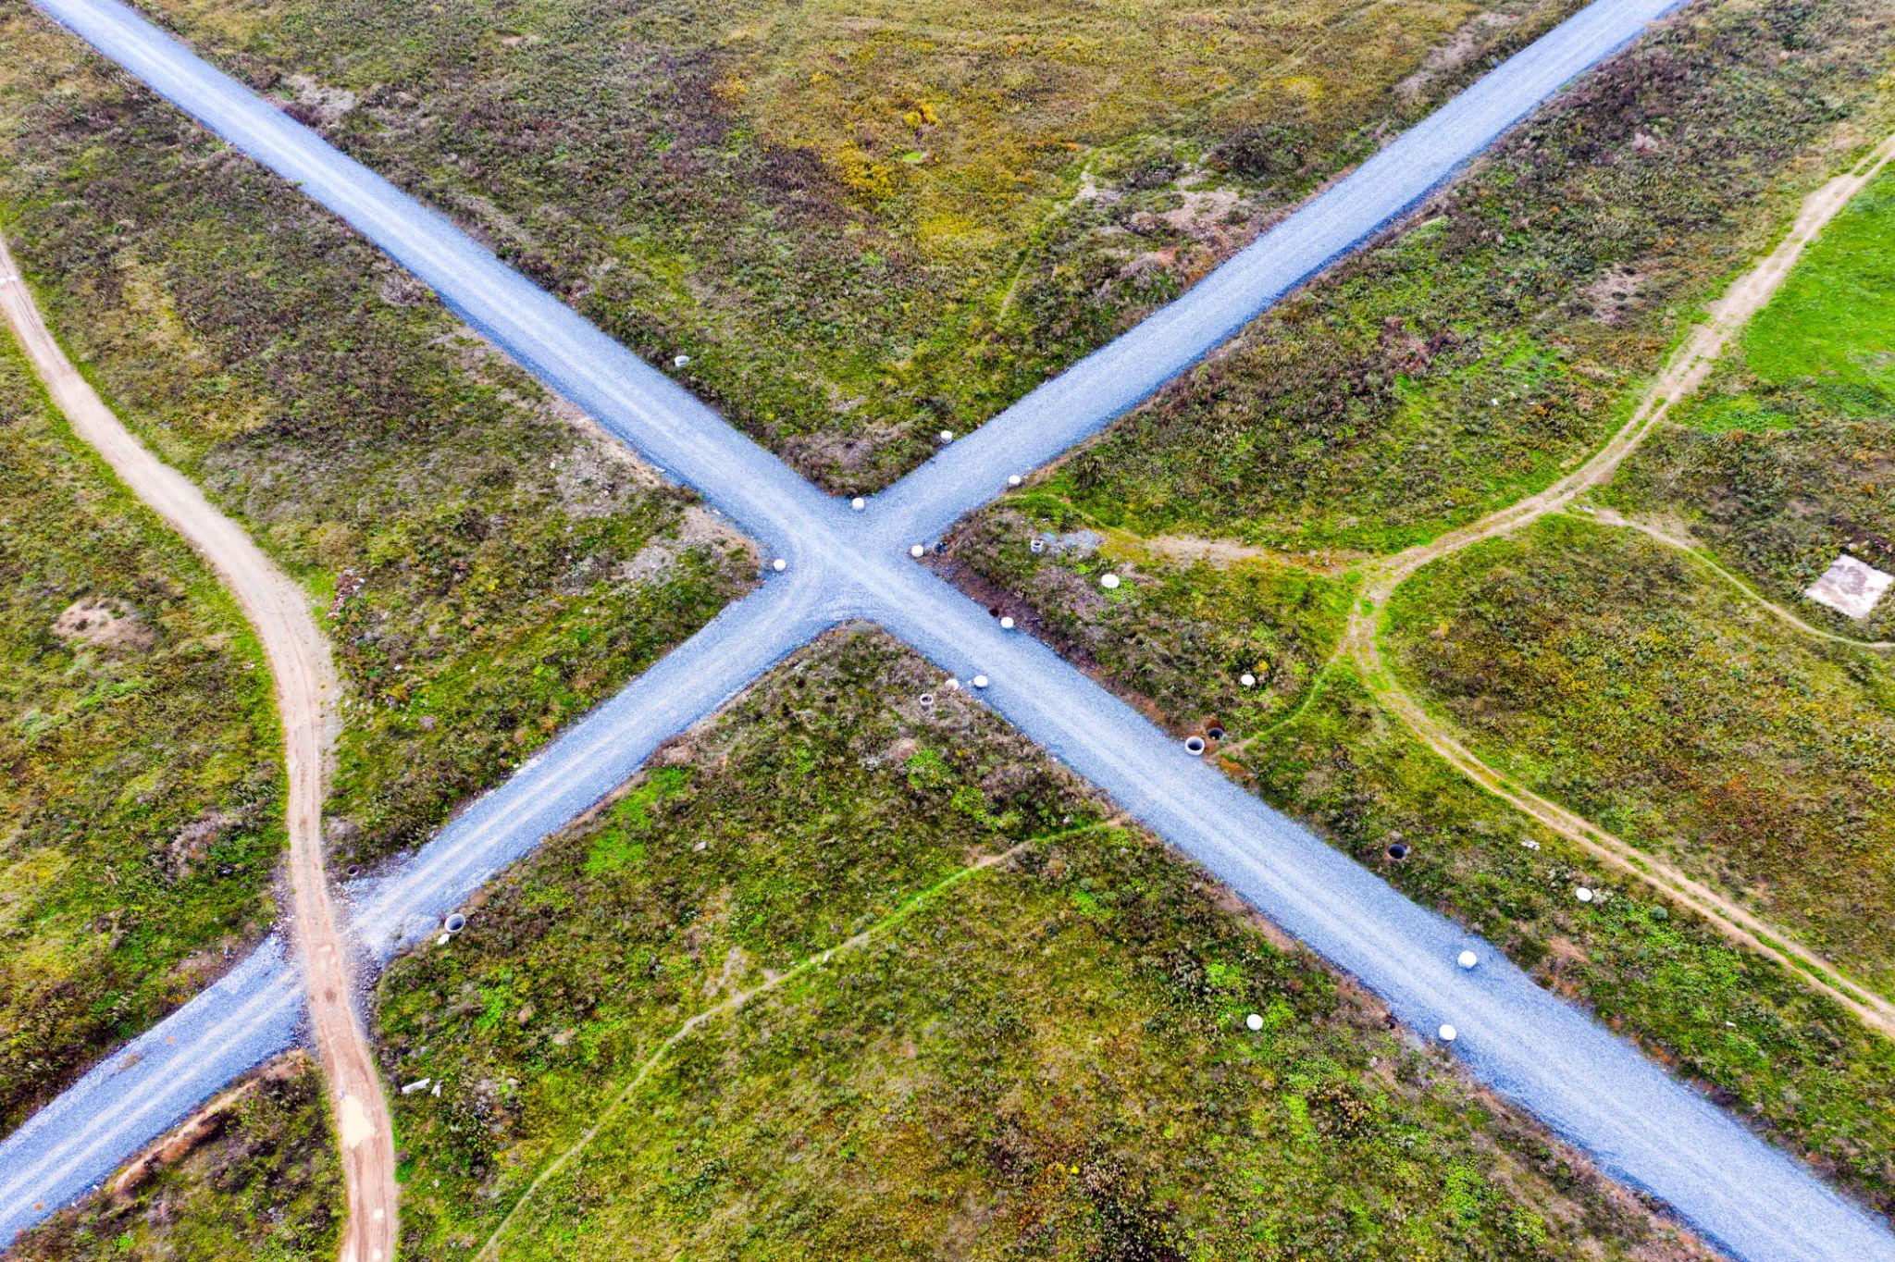
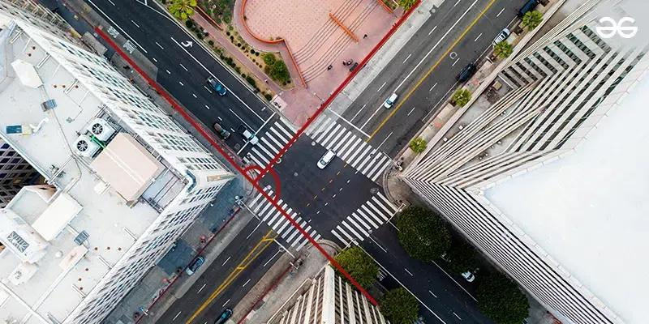
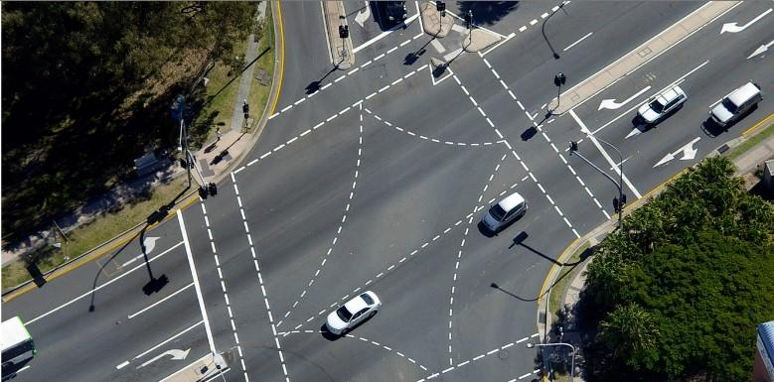
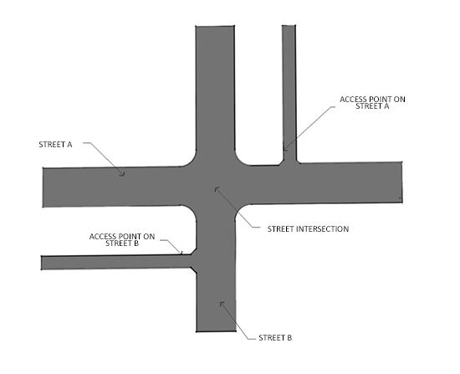

Mathematical Representation
# Source: AI Source: Provided by: [Data Path: Persons Table -> ID Column: 1, Name_En Column: Motasem Essam] -> From: [ChatGPT] on [7/25/2026]
For two geometric objects $A$ and $B$, if they share exactly one point $P$:
$$\boxed{A∩B=P}$$
The braces indicate that the intersection contains one element.
For example:
$$\boxed{\overline{AB}∩\overline{CD}=P}$$
means that the two line segments have exactly one common point.

Important Conditions
# Source: AI Source: Provided by: [Data Path: Persons Table -> ID Column: 1, Name_En Column: Motasem Essam] -> From: [ChatGPT] on [7/25/2026]
For a point intersection to occur:
- The objects must have at least one common point.
- They must not share a second point.
- The common point must belong to all objects being considered.
Therefore:
$$\boxed{\text{Exactly one common point}}$$
is the defining condition.

Point Intersection vs. Other Types of Intersection
# Source: AI Source: Provided by: [Data Path: Persons Table -> ID Column: 1, Name_En Column: Motasem Essam] -> From: [ChatGPT] on [7/25/2026]
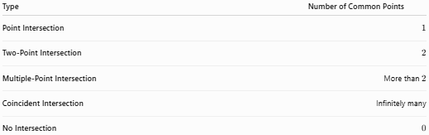
Type | Number of Common Points
Point Intersection | $$1$$
Two-Point Intersection | $$2$$
Multiple-Point Intersection | More than $2$
Coincident Intersection | Infinitely many
No Intersection | $$0$$
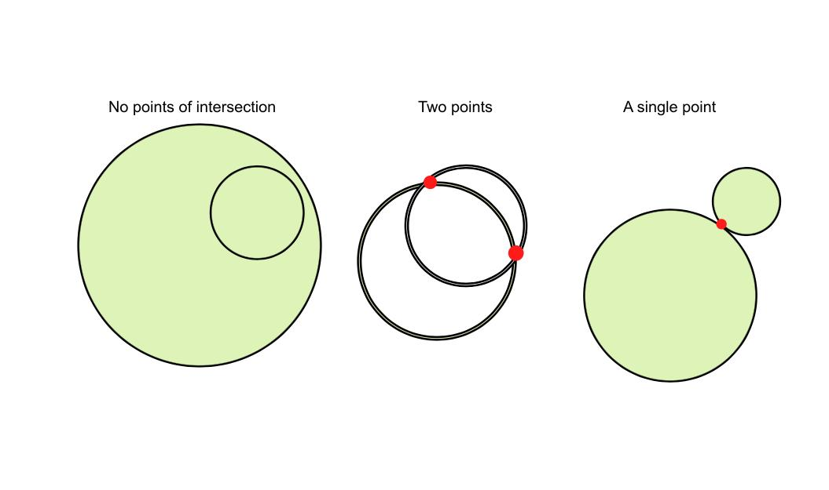
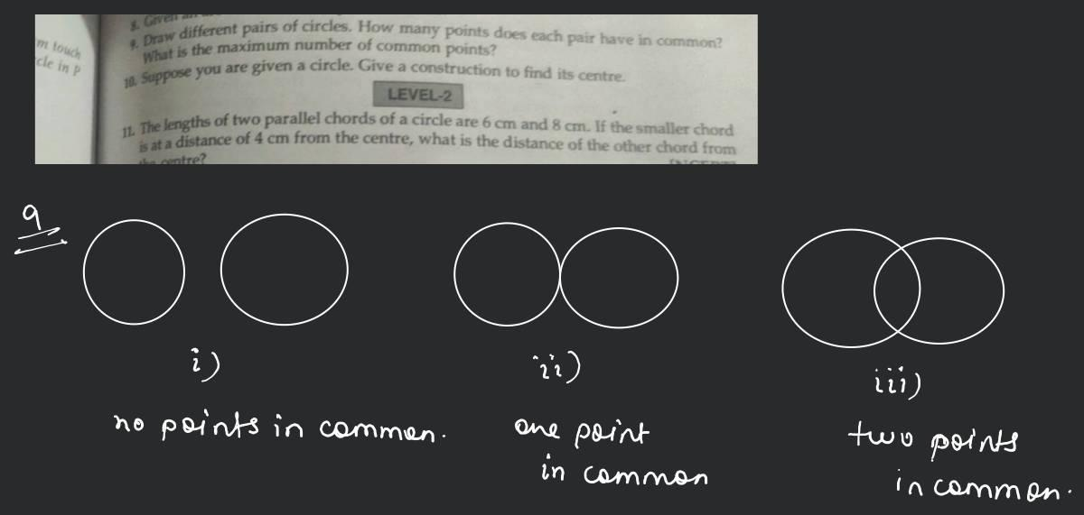
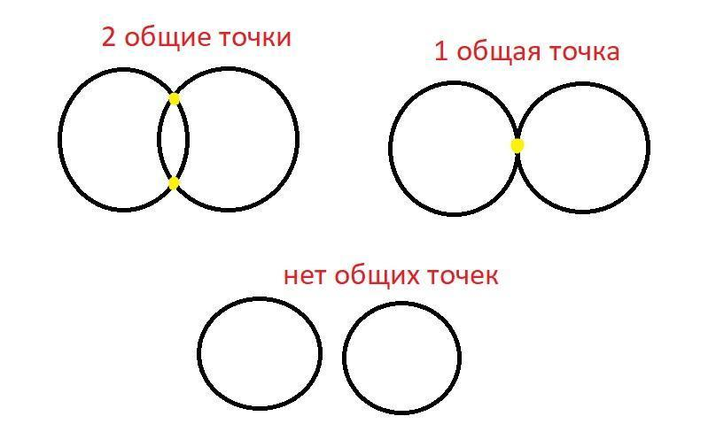

Point Intersection vs. Coincident Objects
# Source: AI Source: Provided by: [Data Path: Persons Table -> ID Column: 1, Name_En Column: Motasem Essam] -> From: [ChatGPT] on [7/25/2026]
These should not be confused.
Point Intersection
Objects share exactly one point:
$$\boxed{A∩B=P}$$
Coincident Objects
Objects share infinitely many points:
$$\boxed{A∩B=A}$$
For example, two identical lines are coincident, not point-intersecting.

Point Intersection vs. Two-Point Intersection
# Source: AI Source: Provided by: [Data Path: Persons Table -> ID Column: 1, Name_En Column: Motasem Essam] -> From: [ChatGPT] on [7/25/2026]
A line and a circle provide a useful comparison.
Tangent
One common point:
$$\boxed{l∩C=P}$$
Secant
Two common points:
$$\boxed{l∩C=A,B}$$
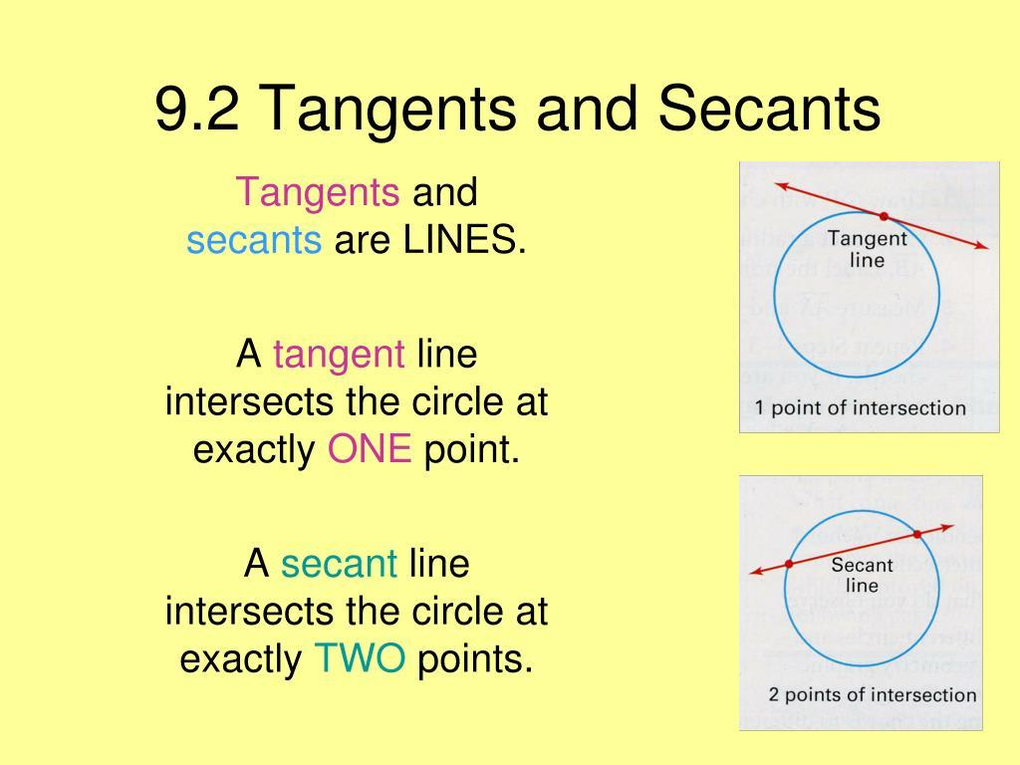
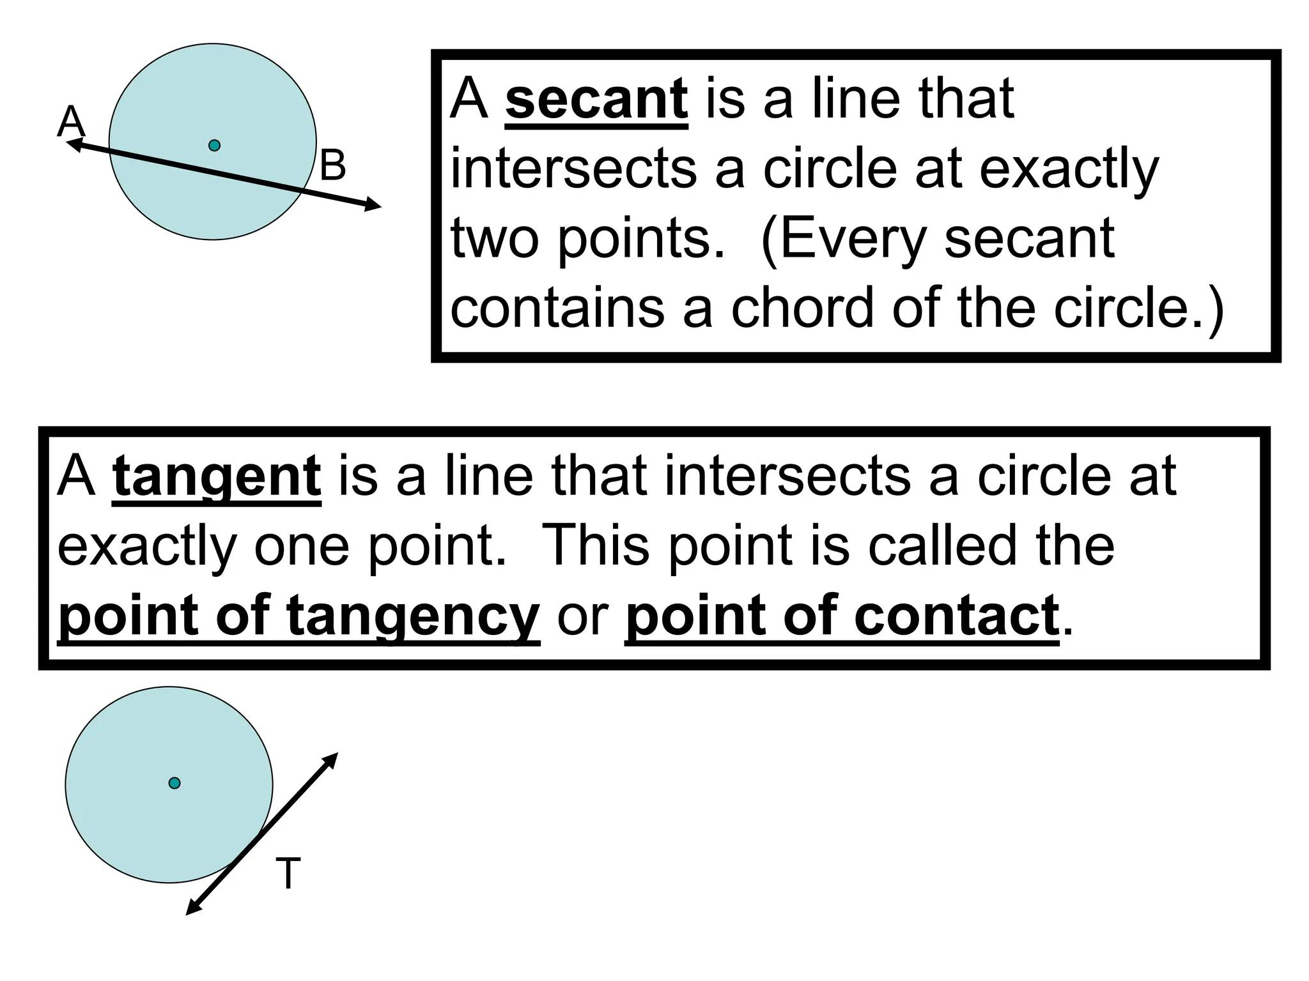
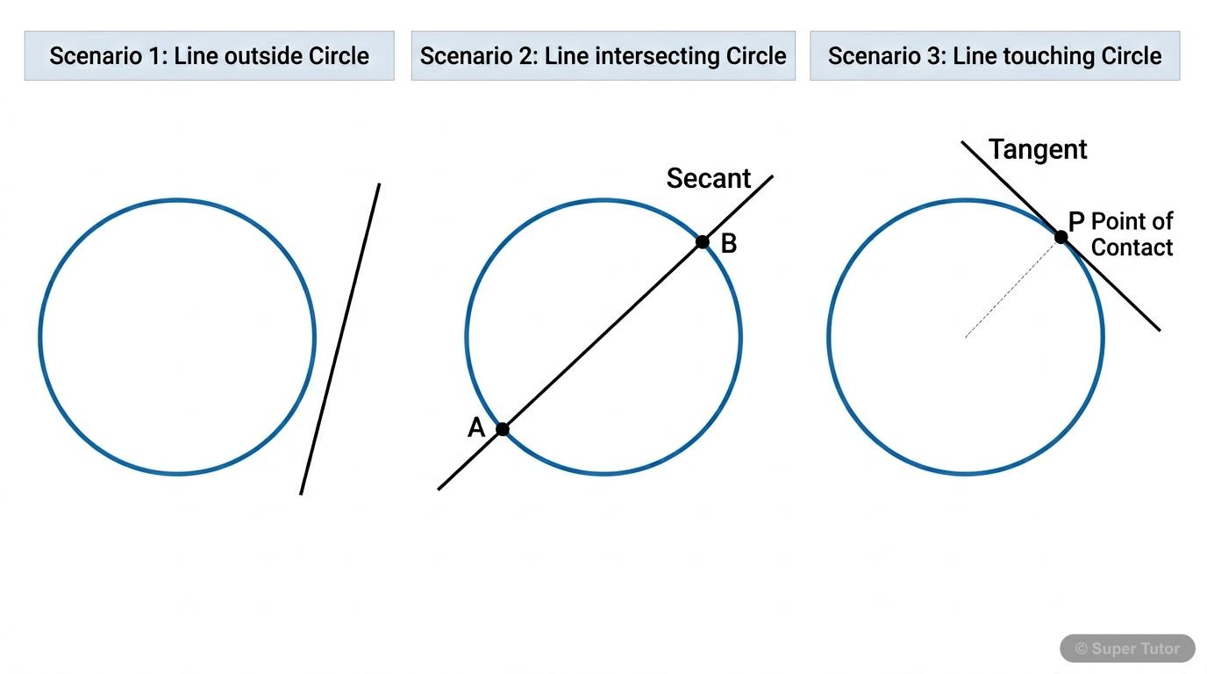
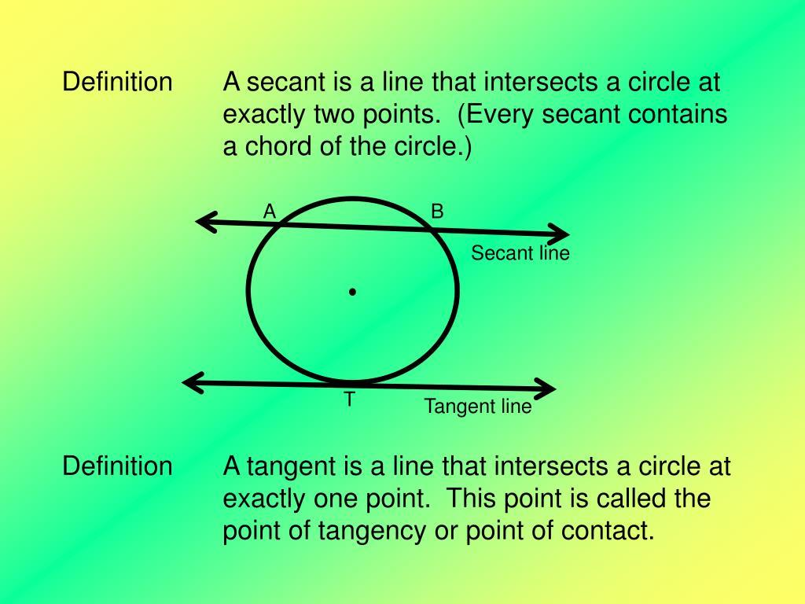

Applications
# Source: AI Source: Provided by: [Data Path: Persons Table -> ID Column: 1, Name_En Column: Motasem Essam] -> From: [ChatGPT] on [7/25/2026]
Point intersection is important in:
- Plane Geometry
- Coordinate Geometry
- Euclidean Geometry
- Algebra
- Trigonometry
- Triangle Geometry
- Architecture
- Engineering
- Surveying
- Cartography
- CAD
- GIS
- Computer Graphics
- Robotics
- Navigation

Advantages
# Source: AI Source: Provided by: [Data Path: Persons Table -> ID Column: 1, Name_En Column: Motasem Essam] -> From: [ChatGPT] on [7/25/2026]
Studying point intersections helps to:
- Locate exact geometric positions.
- Solve systems of equations.
- Find crossing points.
- Analyze geometric constructions.
- Determine triangle centers.
- Find tangent points.
- Analyze polygon structures.
- Model real-world intersections.
- Build accurate CAD models.
- Perform collision and intersection calculations in computer graphics.

Limitations
# Source: AI Source: Provided by: [Data Path: Persons Table -> ID Column: 1, Name_En Column: Motasem Essam] -> From: [ChatGPT] on [7/25/2026]
Point intersection:
- Requires exactly one common point.
- Does not describe objects sharing multiple points.
- Does not describe coincident objects.
- Does not occur between distinct parallel lines.
- Can be difficult to determine visually when diagrams are complex.
- In three-dimensional geometry, two objects may appear to cross in a drawing without actually intersecting in space.

Comparison with Related Concepts
# Source: AI Source: Provided by: [Data Path: Persons Table -> ID Column: 1, Name_En Column: Motasem Essam] -> From: [ChatGPT] on [7/25/2026]
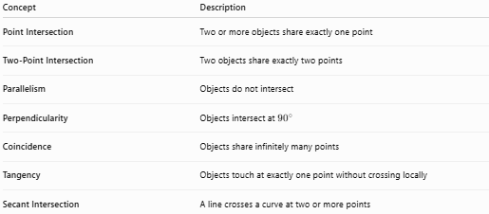
Concept | Description
Point Intersection | Two or more objects share exactly one point
Two-Point Intersection | Two objects share exactly two points
Parallelism | Objects do not intersect
Perpendicularity | Objects intersect at ${90}^{∘}$
Coincidence | Objects share infinitely many points
Tangency | Objects touch at exactly one point without crossing locally
Secant Intersection | A line crosses a curve at two or more points

Key Points
# Source: AI Source: Provided by: [Data Path: Persons Table -> ID Column: 1, Name_En Column: Motasem Essam] -> From: [ChatGPT] on [7/25/2026]
- Point Intersection occurs when two or more geometric objects share exactly one common point.
- The common point is called the point of intersection.
- It can be represented as:
$$\boxed{A∩B=P}$$
- Two non-parallel lines normally have one point of intersection.
- Two line segments can intersect at one point.
- A tangent line and a circle have one common point.
- Two tangent circles can have one common point.
- In coordinate geometry, the intersection is represented by an ordered pair:
$$\boxed{P=\left(x,y\right)}$$
- Perpendicular lines are a special case of point intersection:
$$\boxed{A∩B=P, ∠P={90}^{∘}}$$
- Point intersections are widely used in geometry, algebra, engineering, surveying, CAD, GIS, and computer graphics.

Conclusion
# Source: AI Source: Provided by: [Data Path: Persons Table -> ID Column: 1, Name_En Column: Motasem Essam] -> From: [ChatGPT] on [7/25/2026]
Point Intersection is a fundamental type of Intersection in geometry in which two or more geometric objects share exactly one common point. This point is called the point of intersection and can be represented mathematically as $A∩B=\{P\}$. Point intersections occur between lines, line segments, rays, circles, curves, polygon elements, and other geometric objects. They are especially important in coordinate geometry, where an intersection represents a common solution to equations, and in practical fields such as architecture, engineering, surveying, CAD, GIS, robotics, and computer graphics.

